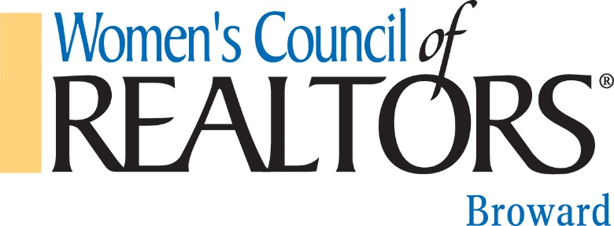

Dear Treasured Strategic Partners,

As your 2017 Broward President, I appreciate your continued support to our network. It is my pleasure to extend this special invitation for you and your company to participate as a Strategic Partner and to play an instrumental role in our success throughout 2017.

Becoming a Strategic Partner for Women’s Council of REALTORS® (WCR) provides many benefits including: networking, advertisement, referrals, and educating our community. Gold and Platinum levels enhance partnership by giving you the opportunity to speak and promote your business during our Business Resource Meetings. More importantly, this is a network that provides a platform for its members and affiliates to showcase the talents that makes Women’s Council a real estate industry leader.

In order to get your business the recognition it deserves, we invite you to participate in being an annual Strategic Partner.

We are offering the following three levels of Strategic Partnership Opportunities: Platinum, Gold, and Bronze (benefits for each are attached). Payment plans can be coordinated if so desired.

Please contact me at wcrbroward@gmail.com should you have any questions or would like to discuss the potential benefits Women’s Council of REALTORS® can provide you and your business.

Your support is greatly appreciated,

Venus Proffer, PA
2017 WCR Broward Network President
Direct: 954-816-8992
E-mail: wcrbroward@gmail.com

Women’s Council of REALTORS® Broward Network
2017 Strategic Partnership Opportunities and Benefits
PLATINUM YEARLY STRATEGIC PARTNER - $ 1,350
- A WCR one (1) year membership to NATIONAL (or renewal when it comes up for 2017)
- Member Spotlight on WCR Broward Network’s Facebook website to promote your business and industry
- MUST become a member of the local board to become a Strategic Partner
- Opportunity to speak for 2 minutes and promote your business at (2) Two Business Resource Meetings in 2017.
- Two (2) tickets for our 2018 Installation in December 2017
- Twenty five percent (25%) off a Sponsor Table at our Special events including Fashion show, District, and Casino night.
- Three (3) complimentary admissions to Business Resource Meetings AND complimentary Admission for a NEW REALTOR you bring to (3) Three meetings (Required)
- Company name and logo to be displayed as “Platinum Sponsor” at all Business Resource Meetings, fundraisers, and networking events.
- Recognition at Business Resource Meetings, fundraiser, and networking events
- Brochures displayed on Sponsor Table at monthly Business Resource Meetings, fundraisers, and networking events
- Company name and logo on WCR Broward Network website with link to your company website
- Company name and logo to appear on e-mail announcements and Facebook Advertisements Monthly
- Copy of all attendees’ business cards for Business Resource meetings.

GOLD YEARLY STRATEGIC PARTNER - $850
- Opportunity to speak for 2 Minutes and promote your business at one (1) of our Business Resource Meetings in 2017.
- One (1) ticket for our 2017 Installation in December 2016
- Ten percent off (10%) a Sponsor Table at our Special events including Fashion show, District and Casino night.
- TWO (2) complimentary admissions to Business Resource Meetings and complimentary admission for a NEW REALTOR you bring to (2) Two meetings (Required)
- Company name and logo to be displayed as “Gold Sponsor” at all Business Resource Meetings, fundraisers, and networking events
- Recognition at Business Resource Meetings, fundraiser, and networking events
- Brochures displayed on Sponsor Table at monthly Business Resource Meetings, fundraisers, and networking events
- Company name, and logo on WCR Broward Network website with link to your company website
- Copy of all attendees’ business cards

BRONZE STRATEGIC PARTNER - $350
- Member pricing at all local events.
- One (1) complimentary admission to a Business Resource Meeting and complimentary Admission for a NEW REALTOR you bring to (1) One meeting (Required)
- First Choice to sponsor at our Special events (Fashion, District conference and Casino night)
- Five percent off (5%) a Sponsor Table at our Special events including Fashion show, District and Casino night.

IN-KIND Sponsors ALSO AVAILABLE!
- One (1) Provide your venue location, meals, printing, office supplies, services, etc. for one of our events or throughout the year

