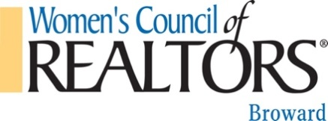 2017 Calendar of Events (subject to change)

2017 Governing Board

President January 6 12:00pm Governing Board Meeting
Venus Proffer January 18 12:00–1:30pm Bus. Res. Meeting @ GFLR EAST January 24-28 Florida REALTORS Mid-Winter meeting Orlando

President Elect February 2 12:00pm Governing Board Meeting
Chris Ricci February 15 12:00-1:30pm Bus. Res. Meeting @ DCOTA

VP of Membership March 8 Social Mixer (100 Las Olas)
Brandy Whitford March 24 Fashion Show – Coral Ridge Yacht Club
March 28-29 Great American Realtor Days (Tallahassee)
Treasurer
Janie Rose April 7 12:00pm Governing Board Meeting
April 19 12:00 -1:30pm Bus. Res. Meeting @GFLR WEST
Secretary
Stacey Fiore May 18-21 REALTORS Mid-Year Legislative Meetings (D.C.)
May 24 Member Orientation- Member only (Robovault)
Standing Committees
June 2 12:00pm Governing Board Meeting
Education/ Programs June 16 District Conference (TBD)
Open
July 7 12:00pm Governing Beard Meeting
Ways & Means July 19 12:00-1:30pm Bus Res. Meeting @ DCOTA
Billi Sieden
August 15-20 Florida Realtor Convention-Orlando
Bylaws & Parliamentarian August 31 12:00pm Governing Board Meeting
Lisa Vizcaino/Jason Aybar
September 20 12:00–1:30pm Bus. Res. Meeting @ Galuppi’s
Active Past President
Sharon Lindblade October 7 Disco theme Casino Night
October 20 12:00pm Governing Board Meeting
Finance & Budget October 25 12:00-1:30pm Bus. Res. Meet. @ Sawgrass
Janie Rose
November 1-5 NAR Convention-Chicago
Membership November 15 Member Orientation -Members only (TBD)
Brandy Whitford
December 1 Installation (TBD)
Nominating
Sharon Lindblade

Social Media
Danielle Clermont

