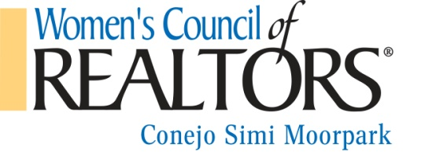
STRATEGIC PARTNER
$175/year January – December 2016
We are pleased to offer the following Strategic Partner which is designed for an INDIVIDUAL, benefits include:
- Entry fees for Business Resource Meetings and Events at Realtor member rate (one person only)
- Your individual information on all Business Resource Meeting programs. Details include name, company, one phone #, one email, one website address, and your category (ex. pest control, lender, etc.)
- Individual is eligible to be an event sponsor for a particular event, for a separate fee.
- Your Individual information included in the WCR Membership Directory
- Free Attendance at all Mixers
- Complimentary participation in our WCR Expo
Please include the following information:
Company name _____________________________________________
Phone number_______________________________________________
Email _____________________________________________________
Website address_____________________________________________
Category/type _______________________________________________
Company logo (jpeg) ***please send as a jpeg attachment
Please complete the above application (deadline is 1/31/16) with a check for $175 payable to Women's Council of Realtors and mail to:
Women’s Council of Realtors
c/o Simone Yallouz, Treasurer
Planatek Financial
340 N. Westlake Blvd Ste 240
Westlake Village, CA 91362
Payment by credit card can be arranged. Please contact us for details.
If you have any questions, please contact our Sponsorship Chair, Carol Salgado 818-631-5554 (cell) or CSalgado@lfcu.com. Or, President Tamara Campbell, 805-750-6577 (cell) or Tamara@CallTamara4Homes.com.
Thank you for your continued support!
Rev.12/15

