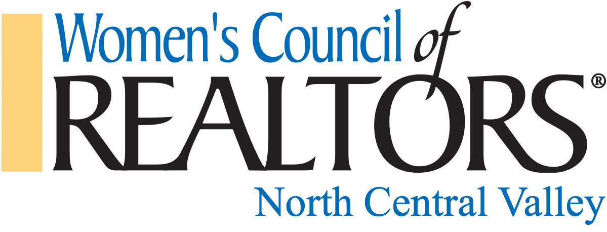

2022 SINGLE EVENT SPONSORSHIP OPPORTUNITIES

VI. Single Event Sponsorships
The following are to be used as guidelines for obtaining sponsors when appropriate for various
events, to be determined as needed.

V1a. Event Sponsor:
- Variable rate based on expected attendance and venue. Starting at $250 for under 50 attendees, $400 for 50-100 attendees and $500 for 100+ attendees. Covers or defrays cost of speaker, printed programs and other expenses incurred.
- Sponsor provides a ($25 minimum value) door prize (sponsor receives business cards used for drawing)
- Event Sponsor may provide additional raffle gift

Benefits:
- Check in and greet attendees at the door in the VIP line, where applicable
- Acknowledged at program and gets 2 minutes to promote company
- Receives 1 free admission to event, in addition to 1 free admission for non-member Realtor ® guest who has not attended before
- Logo on programs if it is provided at least 10 days before event.
- Can display banner and provide promotional items on designated table

V1b. Food Sponsor
- Cost varies. Provides food, drinks, dishware and utensils, if needed. Breakfast, Lunch or Dinner to be determined by agreement. $250 Minimum

Benefits:
- Acknowledged at program and gets 2 minutes to promote their company
- Receives 1 free admission to event in addition to 1 free admission for a non-member Realtor ® guest who has not attended before
- Logo on programs if it is provided at least 10 days before event
- Can display banner and provide promotional items on designated table

V1c. Room Sponsor:
- Covers cost of room and/or defrays other network meeting expenses (a minimum of $250)
- Provides raffle gift (a minimum value of $25)

Benefits:
- Acknowledged at program and has 2 minutes to promote their company
Receives 1 free admission to event, in addition to (1) free admission for a non-member Realtor ® guest who has not attended before
- Logo on programs if it is provided at least 10 days before event
- Can display banner and provide promotional items on designated table

