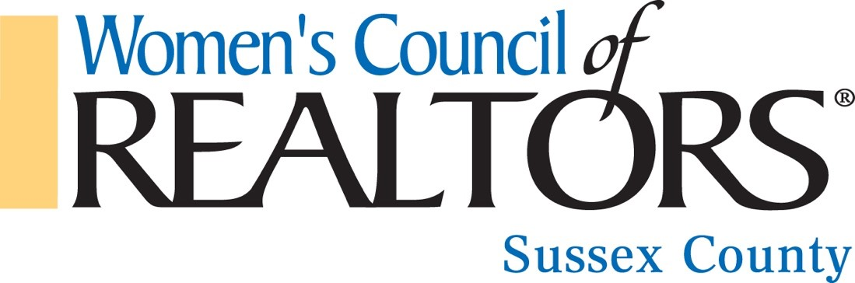
We extend a BIG Thank you to our 2021 Strategic Partners!
Amerispec Home Inspections
Cheryl Myers

CK Management
Bill & Denise McCormick

Creative Concepts
Pat Purdum & Craig Lednum

Cross Country Mortgage
Joe Della Torre

Embrace Home Loans
Wendy Smith

Law office of Scott and Shuman
Billy Scott

Law office of Sergovic, Carmean, Weidman, McCartney & Owens
Shannon Carmean Burton, Deirdre McCartney, Shannon Owens

Law office of Ward and Taylor
Meaghan Hudson & Nancy Law

Law office of Susan P. Weidman
Susan Gardner & Veronica Townsend

Cutko
Russell Wimbrough

Direct Mortgage
Katie Sheats

First Shore Federal
Diane Koch

Please Note: New 2022 Strategic Partner Program Starts 4/1/2022-3/31/2023 – We hope you rejoin us as one of our valued partners starting in April!

