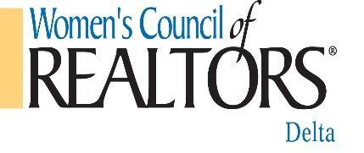 Agenda Delta Board Meeting
April 6, 2022
10:30 – 12:00
Meeting In Person at Loan Depot Rd. Ste. F
Brentwood

Mission Statement:
We are a network of successful REALTORS®, advancing women as professionals and leaders in business, the industry, and the communities we serve.
Vision Statement:
Through our influence as successful business professionals, women will affect positive change in the profession and in the broader community.
Governing Board Meetings are open meetings. Members are welcome to observe. If time permitting, we would love input on a particular subject/topic.
Ground Rules:
• Please turn off cell phones or put them on vibrate.
• Specified Voting Members show with a (V).
• Evaluate ideas, not people, work toward consensus, not standoff.
• Address all comments to the presiding officer and avoid side conversations.
• Respect people’s time; be brief, stay on topic.

Chairperson: - Jessica Robinson 2022 President
l. Call to Order -
ll. Approval of Agenda –
Motion:
2:
lll. Approval of Minutes-
Motion:
2:
IV. Financial Report – Jody Drewry Treasurer
Update on 2022 current budget and any information needed for account reconciliation

V. Reports of Officers and Standing Committees:

A.
President- Jessica Robinson
Day At The Races Update
Strategic Partners Updates

B.
President-Elect – Rwan Rasheed
Update on Spring conference
Questions/Concerns

C.
Secretary – Sharleen Milland
Questions/Concerns

D.
Event Director – Michele Dotson
April ADU updates
Questions/Concerns

E.
Membership Director – Virginia Viera-Mitchell
Update on new members/current members count
Update on upcoming members meet up
New Membership News
Questions/Concerns

F.
Strategic Partner Director – Jennifer Britton
New Strategic Partner opportunities
Questions/Concerns

G.
Hospitality-Maria Bruno
Questions/Concerns

H.
I.T.-Anthony Silva
Quick discussion on best options for media, laptop/monitor/speakers/mike
or projector
Questions/Concerns

I. Financial Budget Review Concerns Cecily Tippery

VII. Special Committee Reports (reports only on active events or updates)

VII. New Business
Review reimbursement protocol
Review standing rules and bylaws.

VIII. Old Business
Is there anything from the past that has not been addressed and answered prior to going into our next meeting on May 11, 2022

IX. Adjournment

