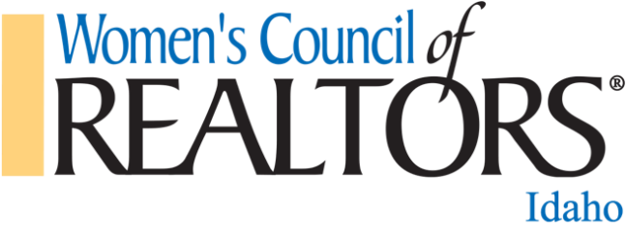

Women’s Council of REALTORS® - Idaho
July 14, 2022 at 3:00 PM MST
Executive Committee Meeting Minutes

Call to Order: Sarah Libengood 3:00 PM MST
Members in attendance: Sarah Libengood, Nicole Beebe, Tom Turner, Tami Sims & Kim Sitton.

Treasurer’s Report: Current Balance $22,645.62 ($17,643.84 in checking and $5001.78 in savings). Chris Lee fundraiser is at $2139.71-$650 sponsorship & $1300 ticket sales-the goal is $2500.
Sarah said we should check Boise Metro to see where they are with their sales.
Tami has still not heard from Kristin Short about her sponsorship.
Bill Highway: Cash balance for the dues through 7/14/2022 is $2668.75
Updated Bylaw Templates: They need to be downloaded, add in our current name and dues info, and upload to the microsite so we have the correct ones there for our network certification. Sarah still can’t get logged in and said if she doesn’t get in pretty soon, she is going to reach out to Kim and see if she can assist her.
Tami is going to send out the invoices to the local networks for their $500 annual fee and another invoice for $450 ($75 for each of the 6 board member that is supposed to attend the training in Cd’A)

Upcoming Events:
6/1-State Liaison due date-Antigone Twidt (done)
6/1-Application date for Leadership Institute begins and Nicole LeRossi from North Idaho and Tom Turner have submitted their applications.
LID Committee-has turned in recommendations.
7/27-7/29-Networking 360 (PE & State Liaison to Chicago for President Training)
8/1-Application for Network Certification begins (due 10/1)
8/11 Governing Board Meeting 3:00pm MST

Elections: 8/11/2022
Mary Smith-First Vice President, Dianna Haug-Treasurer Tom Turner-President Elect.

ID State Meeting/State Training 10/3-10/9
From Amanda Pannell apannell@idahorealtors.com:
The meeting is on Friday, October 7th from 1:30pm-4:30pm. I am working on rooms and will get that info to you soon. Yes, the joint reception is on Wednesday, October 5th from 6:30pm-8:30pm in Casco/Kidd/Cape. I am still confirming events, but should have the agenda available in the next week or so.
10/5-Joint Convention Joint-Marta still has no idea. We need to get our heads together asap.
-Free Headshot Event
-Silent Auction Items
10/8-Meeting of the Members
10/8 State Training-8:30 AM PST sign in/Meeting starts at 9:00 AM PST-Nicole Beebe

Network Reports:
Boise Metro- Recent Fundraisers:
Bunco Night: April 8th, Net Profit: $750.00
Hubble Homes Happy Hour Spring Parade: May 18th, Net Profit: $1500.00
Denim & Diamonds: June 24th, Net Profit: $8500.00

Upcoming Events:
July 13th, Breakfast Meeting, Who "R" We Panel
August 10th, Jimmy Farris "Be A Pro"
August 17th: Membership Appreciation BBQ (collaboration with Canyon County)
September 14th, Breakfast Meeting, Broker Panel Mastermind
October 12th, Breakfast Meeting, Ria Allen Pepper Shock Media
November (TBD): Wine Down Officer Installation Party
December (TBD): Annual Christmas Party

Membership:
Realtor Members: 71
National Affiliates: 9
Strategic Partners: 42

Overall the Network is doing well. Our books are pristine and balanced. We had anticipated a larger attendance at our Denim & Diamonds Annual Fundraising event, but still made a nice profit.

Canyon County- This month is our community involvement event. July 20th, 4 board members will be participating at Pink on the Dirt with set up.
Our June Paint & Sip Fundraiser was not as successful as we had hoped
Income: 1732.60
Food/Drink: $430.78
Paint: $615
Square Fees: $47.24
Eventbrite Fees: $108
Total Profit: $531.58
Kelsie is out on leave from the board. She did not say how long she would be out on leave. August we are suppose to have a Collaboration with Boise Metro, Fried is working on this and has stepped up to help cover Kelsie's board duties. I'll check in with her for an update. Frieda will also be putting together an email regarding upcoming elections and board positions available, which are
Treasurer
Program Director
Membership Director
Frieda will remain in the First Vice President position
Kelsie last stated she would like to be in the President Elect Position. I will have to confirm with her if she plans to move forward with this. I did sent a message asking all board members who planned to continue on the board and she never responded.
This was last years (2021) fundraiser
Last Years:
Income: $926.21
Food/Drink: $403.20
Paint: $575
Decor: $10.59
Square Fees: $14.90
Eventbrite Fees: $171.50
Total Profit: -$248.98
Mina Piña, Realtor®️
Southeast Idaho-Good morning! Our network is doing well! Our last event was a Q&A panel and our next three events are July 29th a luncheon with a guest speaker, Aug 31st Rock n' Bowl, a bowling alley event, and Sept 22nd a luncheon called Bra's 4 a Cause! We have been making budget arrangements for CDA in October and we will have an event called Witches Night Out on Oct 26th!

North Idaho- These are the events for the rest of the year. The boat cruise was a success. Our next fundraiser is WCR gives back we are adopting a couple of kindergarten and or first grade classes and doing a drive for school supplies. The group is doing fine they should and out the year well. We are getting a bit better on communication so that is good.
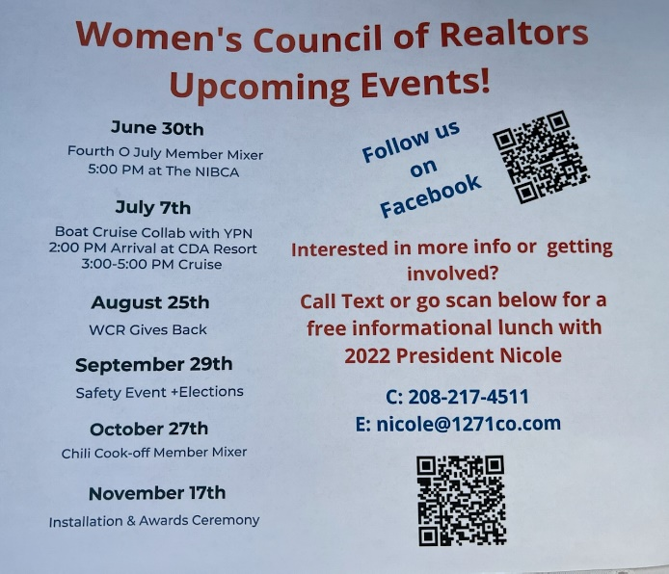
These are the events for the rest of the year. The boat cruise was a success. Our next fundraiser is WCR gives back we are adopting a couple of kindergarten and or first grade classes and doing a drive for school supplies. The group is doing fine they should and out the year well. We are getting a bit better on communication so that is good.

Other Business: Past Presidents Scholarship- need to start a campaign for that.
Sarah is going to talk to the local networks about their fundraising going toward WCR events more than community events.
Sarah went to Oregon’s WCR and spoke, and while there, they talked about doing a joint event with Idaho. Sarah and Kim are going to work with Nicole to see if doing one next year might be possible.

Next Meeting: Aug 11, 2022 at 3:00 PM MST

Meeting Adjourned: 3:47 PM MST

