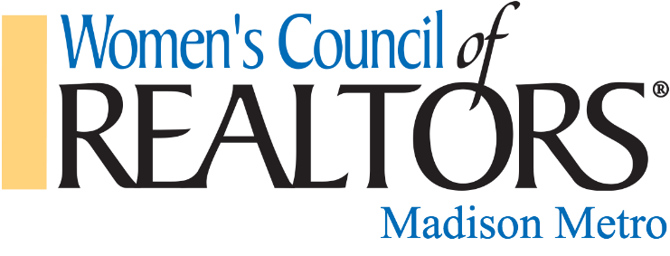

Scholarship Application

Name: ___________________________________________________
Company Name: ___________________________________________
Company Address: _________________________________________
City: _____________________ Zip: _____________
Phone: ____________________ Email: ________________________
Years in Business: __________ Years with WCR Madison: _________
What Women’s Council Committees did you actively participate in for the current year? And what was your role? ( ex: Registration, Membership, Events) _____________________________________________________________________________________________________________
Are you willing to serve on a committee next year? If so, which ones? __________________________________________________________
What convention, conference, or educational training are you using your scholarship for? (can not include CE) ____________________________________________________________________________________________________________________
Amount requested: _____________ (please provide proof of payment)
Email completed application to Carla Nowka cjm@ptitle.com or mail to 2728 Coho St., Madison, WI 53713
Deadline is December 15th!
Revised 11/22/23

