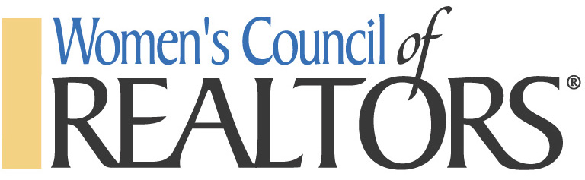
For Immediate Release
MEDIA RELEASE
Ocean County Achieves Network Certification for 2022-2023

Ocean County Network, October 20, 2022. Ocean County has obtained the Women’s Council Network Certification, a program that recognizes and rewards the most active local and state networks that achieve five key benchmarks of network excellence and exceeds basic charter requirements per its national affiliation and provides outstanding member service.

The certification program ensures that members receive quality service in benchmarks related to member services, leadership development, administration and governance, communications, recruitment and retention. While networks keep a charter with national by meeting baseline criteria, only certified networks are recognized as networks of excellence that meet or exceed rigorous benchmarks.

About Women’s Council of REALTORS®
Women’s Council of REALTORS®, a proud affiliate of the National Association of REALTORS® (NAR) advances women as business leaders in the industry and in the communities served. With 12,000 members nationwide, its proven business leadership is evidenced by the “super-sized” high percentage of its members in leadership positions at NAR, the real estate industry and in local communities, as well as the highest participation levels in the REALTORS® Political Action Committee. The 84-year-old organization is headquartered in Chicago, IL. For more information, please visit WCR.org.

