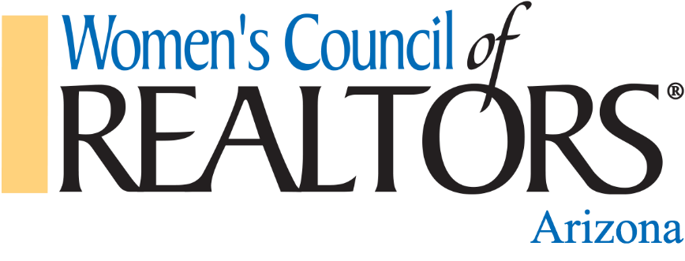

STRATEGIC PARTNER
Program Guide 2024

We Educate, Train, & Support Leaders in the Real Estate Industry and in the Communities We Serve!

Our Mission
We are a network of Successful REALTORS®, advancing women as business leaders in the industry and in the communities we serve.

Our Purpose
The purpose of the Women’s Council of REALTORS® Arizona is to support local networks as they offer an excellent member experience and develop strong leaders for our Council, our Profession, and our Community.

2024 Statewide Board of Directors
President: Stephanie Grande, Tucson
President-Elect: Allison Paoli, Lake Havasu City
First Vice-President: Bryan Anderson, White Mountains
Treasurer: Susan Struse, Sierra Vista/Cochise County
State Liaison: Marleny Gomez, Surprise
District Vice-President: Cherie Stall, Northwest Valley
District Vice-President: Tracy Duncan, Phoenix

Dear Business Professional,

As a Strategic Partner with the Women’s Council of REALTORS® Arizona, you become part of the “Business Resource Center” in the communities our eight networks serve. Our 2024 Strategic Partner Program affords you the opportunity to network and develop relationships with our 400+ members throughout the year.

Women’s Council of REALTORS® Arizona Network meets a minimum of three times a year, a Spring Event, a Leadership Orientation, and a Winter Event & Incoming Officer Installation, as well as hosting Zoom education throughout the year.

Women’s Council of REALTORS® is the industry’s source for strong, committed, well trained leaders that was established in 1938 and continues to be relevant to the industry today. Developing leaders is the Council’s core purpose and strength. The Women’s Council of REALTORS® members share a set of values in how they run their businesses with integrity, collaboration and a commitment to excellence and continuous development. The Women’s Council of REALTORS® prepares women and men to take on leadership roles in real estate organizations and in the communities they serve. Members openly share their expertise, experience, and support each other’s development as professionals.

We are excited for you to join this amazing organization as a 2024 Strategic Partner. With your support, we will reach our goals!

Sincerely,

Stephanie Grande
2024 President

