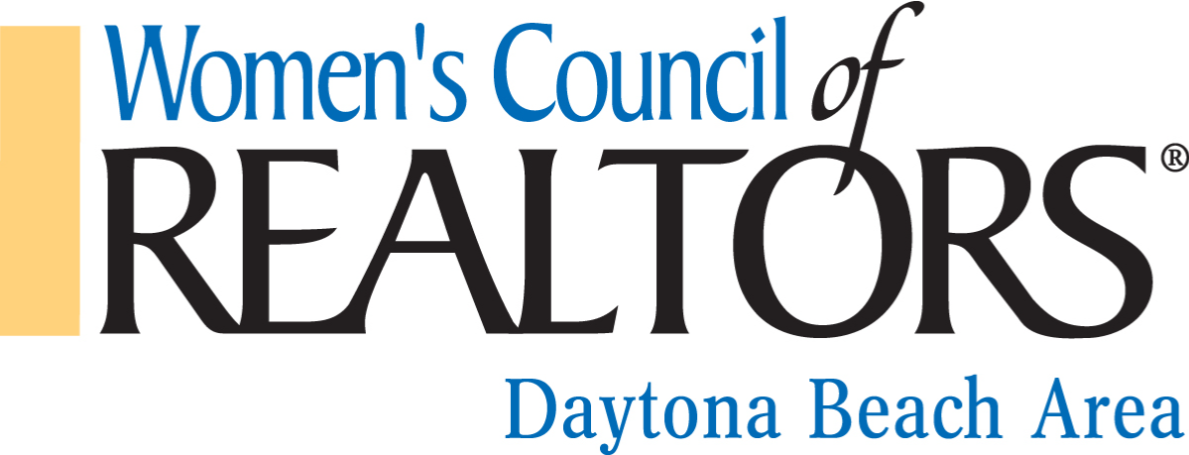
2024 Calendar of Events

1ST QUARTER | EVENT | LOCATION
January 17 -19 | WCR Mid-Winter Meeting and Installation | Hyatt Regency  Orlando
January 24 | Gary Yeomans Lincoln -Happy Hour and Headshots  5:30-7:00 PM | 1410 N Tomoka Farms Rd.  Daytona Beach
February 2 | WCR Governing Board Meeting | ZOOM
February 1-2 | WCR Elevate Virtual Summit | Virtual Event
February 16 | Top Gun Awards Night  6:00- 9:00 PM | Museum of Arts and Sciences  352 S Nova Road Daytona Beach 32114
March 20 | WCR Governing Board Meeting | ZOOM
2ND QUARTER | EVENT | LOCATION
April 17 | WCR Governing Board Meeting | ZOOM
April 5 | RPAC Event with DBAAR and NSBBOR | TBD
April 24 | Parade of Homes Tour | Tanger Outlets
April 26 | District 2 Meeting with Alisa Rogers | TBD
May 15 | WCR Governing Board Meeting | ZOOM
May 7-9 | Mid Year Meeting | Westin Washington Downtown DC
May 17 | Insurance Industry Event | TBD
June 19 | WCR Governing Board Meeting | ZOOM
June 21 | Team Building and Lunch and ELECTIONS | TBD
3RD QUARTER | EVENT | LOCATION
July 17 | Governing Board Meeting | ZOOM
July 17 or 18 | Christmas In July Event | TBD
August 21 (may be rescheduled) | Governing Board Meeting | ZOOM
August 8 | Strategic Partner Appreciation | TBD
September 18 (2025 Board invited) | Governing Board Meeting | ZOOM
4TH QUARTER | EVENT | LOCATION
October 16 (2025 Board invited) | Governing Board Meeting | ZOOM
October 9 | Networking Happy Hour | Grind Gastro Pub, Ormond Beach
November 20 (2025 Board leads) | Governing Board Meeting | ZOOM
November TBD | Board Installation | TBD
December 4 | Holiday Social | TBD
December TBD | Summit for 2025 Board | ZOOM

