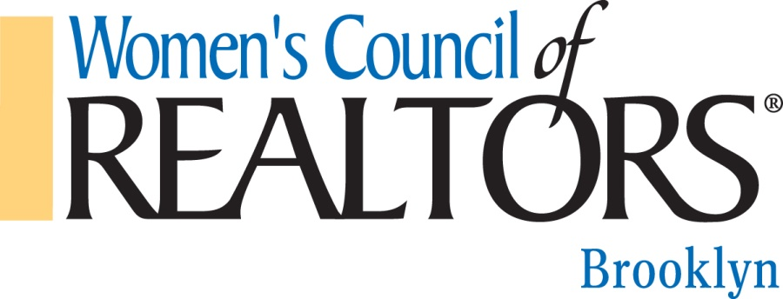

Please circle the appropriate number.
- Women’s Council prides itself on providing exceptional value to its members through effective programming. Please rate relevancy of this program to your business.

Very Relevant <> Not Relevant
5 4 3 2 1

- Please check one:
____I am a REALTOR® Member of this Chapter
____I am a National Affiliate Member of this Chapter
____I am a Local Affiliate Member of this Chapter
____I am a non-Member REALTOR®
____Other/Guest

- Comments/suggestions for future programs:

Please return your evaluation to network officers.

