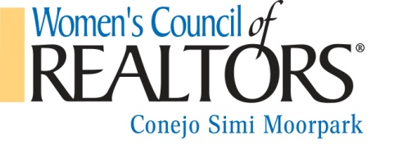
CORPORATE PARTNER
$250/year January –December 2016
We are pleased to offer the following Corporate Partnership which includes:
- Entry fees for Business Resource Meetings and Events at Realtor member rate for each corporate representative
- Your company information on all Business Resource Meeting programs. Details include Company logo, name, one phone #, one email, one website address, and your category (ex. pest control, lender, etc.)
- Your Company is eligible to be an event sponsor for a particular event, for a separate fee.
- Your Company logo on our network page of the WCR National Website
- Your Company information included in the WCR Membership Directory
- Free Attendance at all Mixers
- Complimentary participation in our WCR Expo
Please include the following information:
Company name _____________________________________________
Phone number_______________________________________________
Email _____________________________________________________
Website address_____________________________________________
Category/type _______________________________________________
Company logo (jpeg) ***please send as a jpeg attachment
Payment by credit card and be arranged. Please contact us for details. Please complete the above application (deadline is 1/31/16) with a check for $250 payable to Women's Council of Realtors and mail to: Women’s Council of Realtors
c/o Simone Yallouz, Treasurer
Planatek Financial
340 N. Westlake Blvd Ste 240
Westlake Village, CA 91362
If you have any questions, please contact our Sponsorship Chair, Carol Salgado 818-631-5554 (cell) or CSalgado@lfcu.com. Or, President Tamara Campbell, 805-750-6577 (cell) or Tamara@CallTamara4Homes.com.
Thank you for your continued support!
Rev.12/15

