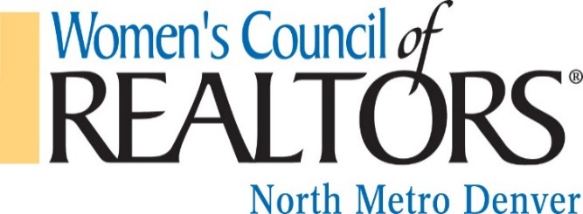

October 28, 2017

Dear Business Owner,

Our 3rd annual fundraising event, Bras for a Cause, is planned for March 11, 2018 at The DoubleTree by Hilton Graystone Castle. Your financial support of Women’s Council of REALTORS® creates a foundation for our mission to be the source of education and business tools that focus on the needs of women REALTOR® entrepreneurs at all stages of their development.

Twenty percent of our net proceeds from this event will be donated directly to Children’s Hospital Colorado Burn Camps Program, the Burn Camps Program meets the psychological and rehabilitation needs of a child and their family following a burn injury. They receive excellent care in hospitals and clinics. At the time of discharge, because rehabilitative stays are limited and reintegration opportunities are limited for young burn survivors, some of these patients need additional support. They need a place to re-process the traumatic pathways that a burn injury can cause. They need an opportunity to connect with other survivors, to be in a supported environment where they are encouraged to challenge themselves and create a full life. Since 1983, Children’s Hospital Colorado Burn Camp has been providing an opportunity for young burn survivors to do this.

We anticipate having up to 150 people attend the Bras for a Cause event where we will have a live and silent auction. We depend on the added support of our friends in the business community who supply us with inspirational auction items. Would you be willing to donate either a gift certificate or merchandise from your business?

Our organization’s ability to continue to operate is due in large part to the generous support of individual donors who believe in our mission, as well as, gifts from businesses and corporations.
Thank you for considering our request. We welcome your presence and participation the evening of our event. For more information about The North Metro Chapter Women’s Council of REALTORS ® please visit our webpage at www.WCRNorthMetroDenver.org or our FaceBook page at https://www.facebook.com/WCRNorthMetroDenver.

Sincerely,

Amy Wagner, Bras for a Cause Project Manager
303-717-5097
AmyWagnerRealtor@gmail.com
North Metro Denver Women’s Council of REALTORS ®
A Not For Profit Organization - Tax ID #47-1138253

