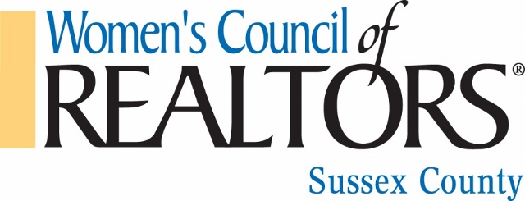
2017 MEETING AND MAJOR EVENTS SCHEDULE
January 17 2:00-4:00 pm Membership Mixer - Mad Hatter High Tea
Tuesday Location: Victoria’s

January 26 10:00-11:15am Governing Board Meeting
Thursday 11:30-2:00pm General Membership Meeting (lunch included)
PROGRAM: “Shift Happens: Adjusting to Consumers; Shifting Communication Needs”
SPEAKER: Adorna Carroll, Dynamic Directions
LOCATION: Victoria’s
2:00-2:30pm New Member Orientation Meeting

January 31 5:30-8:00 pm Membership Mixer - Last Chance to “Get
Tuesday Hooked” on WCR
LOCATION: Hooked Bar at the Midway Shopping Center

February 13 5:00-7:30pm Membership Mixer – Make a LOVE Connection With WCR
Monday Location: Abbott’s Grill, Laurel, DE

February 16 Time 10:00-11:30am Governing Board Meeting
Thursday 11:30-2:00pm General Membership Meeting (lunch included)
PROGRAM: 20 Habits to Refocus and Revitalize Your Career
SPEAKER: Gene Millman
Location: Victoria’s
2:00-2:30pm New Member Orientation Meeting

MARCH 21 Time 10:30-11:30 Governing Board Meeting
Tuesday 11:30-2:00pm General Membership Meeting (lunch included)
Program: Real Estate Investing 101
Speaker: Mike Ferris
Location: Victoria’s
2:00-2:30pm - New Member Orientation Meeting

APRIL 20 10:30 -11:30am Governing Board Meeting
Thursday 11:30-2:00pm General Membership Meeting (lunch included)
PROGRAM: "9 Business Essentials for Every Real Estate Professional"
Speaker: Marc Cunningham
Location: Victoria’s
Drawing for WCR/NAR Mid-Year Conference

May 18-20 WCR/NAR Mid-Year Meetings, Washington DC
NO MEETING One Scholarship to be awarded (travel dates & Scholarship subject to adjustment).
Up to $1,000 to be applied to Scholarship

June 7 5:30-8:00pm 8th Annual Bras for a Cause Fundraiser
Wednesday Location: Ivy On the Bay, Dewey Beach

June 15 10:30 -11:30am Governing Board Meeting
Thursday 11:30-2:00pm General Membership Meeting (lunch included)
Program: “Does Your Business Have Bounce?”
Speaker: Karel Murray
Location: Rusty Rudder

July 20 10:30 – 11:30am Governing Board Meeting
Thursday 11:30-2:00pm General Membership Meeting (lunch included)
Program: “Bridging the Generation Gap”
Speaker: Gee Dunston CEU Session
Location: SCAOR
Drawing for WCR/NAR Conference Scholarship

August No Meeting
August 4-6 2017 Leadership Academy

September 19 10:30-11:30 Governing Board Meeting
Tuesday 11:30-1:00pm General Membership Meeting (lunch included)
1:00pm – 4:00pm CE Class
Program: REAL ESTATE “JEOPARDY” – DOCUMENTS CEU Session – Module 3
Speaker: Nancy Law
Location: Hooked Seafood & Martini Bar – Rehoboth Beach @ The Midway Shopping Center
Elections for 2018 Line Officers

October 19 10:30-11:30am Governing Board Meeting
Thursday 11:30-2:00pm General Membership Meeting (lunch included)
Program: "R.E.A.L.T.O.R.S. With Keys: Finding New Homes for S.T.R.E.S.S."
(Real Estate Agents Looking for Techniques On Reducing Stress)
Speaker: Nicolle D. Surratte
Location: Victoria’s Restaurant

November 1-5 WCR/NAR 2017 National Conference, Chicago, Illinois
One Scholarship to be awarded (travel dates & Scholarship subject to adjustment). Up to $1,400 to be applied towards scholarship.

November 16 5:30-8:30 General Membership Meeting
Thursday Program: Officer Installation Dinner
Location: Victoria’s Restaurant, Rehoboth Beach

