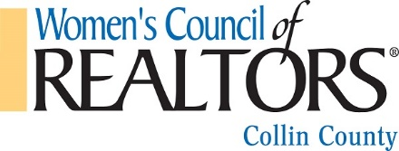
SCHOLARSHIP APPLICATION

Name Company Name Address/City/Zip Phone: Email: Course Name: Course Cost: Course Date:

PRINTED COURSE DESCRIPTION MUST ACCOMPANY APPLICATION
- APPLICANT MUST BE RECOMMENDED BY THEIR BROKER OR A MEMBER OF THE WCR-COLLIN COUNTY GOVERNING BOARD

Years in the Real Estate Business Professional Designations

Years member of CCAR
Years member of WCR
Awards

CCAR/WCR Committees Served on

Member Signature: Date:

BROKER OR GOVERNING BOARD RECOMMENDATION FOR APPLICANT: (List reasons why this

applicant should receive a scholarship for advancement in education and leadership)

Broker or WCR Signature

SCHOLARSHIP QUALIFICATIONS
Date:

SCHOLARSHIP PROCEDURES

*National Member of WCR Collin County for minimum one year.
*Member of CCAR for minimum of 1 year.
*Scholarships cannot used for MCE or license renewal.
*Scholarships may be granted for ABR,CRS,GRI,PMN & other REALTOR® Designations, computer training, grouped education packages, scheduled within a 90 day period and other Real Estate related
and personal growth courses.
* Maximum amount is $300 or the exact cost of course.
* One Scholarship per calendar year, per member.
*Application must be submitted at least 2 weeks prior to course date. Reimbursement will be sent for board approval AFTER receipt of successful course completion.
*Additional consideration will be given to applicants who have been actively involved in WCR or CCAR .
* After board approval scholarships will be paid as funds become available in the approved budget .

Please forward all applications to: DAVID LONG: Scholarship Chair

Ph: 972-567-0520 Email: davidlong@ebby.com

Date Received Date Approved Date to Treasurer Amount Approved Date Paid Check #

