ARE YOU READY?

The Women’s Council of REALTORS® is the 12th largest women’s organization in the country! We are a network of successful REALTORS®, advancing women (and men) as professionals and leaders in business, the industry and the communities we serve.
NETWORKING BUSINESS SKILLS
COMMUNITY INVOLVEMENT EDUCATION
The Fredericksburg Chapter was chartered in 2012. We currently have approximately 42 members, and 11 Local Affiliate businesses. Our Chapter was named 2013 NEW CHAPTER OF THE YEAR out of 230+ chapters nationwide!
Our Programs are designed to ADD VALUE to our members in their professional and personal lives. Here’s a sample of the programs we’ve provided:
- Fredericksburg Mayor Mary Katherine Greenlaw speaking on leadership
- Deputy Sheila Jones demonstrating safety skills for REALTORS®
- A panel of local appraisers sharing the ins and outs of valuing our market
- Lem Marshall speaking on the Mortgage Market (CE credit offered)
- Congressman Rob Wittman
- A panel of top producers from WCR Chapters across Virginia
- Shoes, Sips & Satchels 2013 – an amazing evening offering food, wine, and a silent auction of designer shoes and purses raising over $13,000 to benefit EMPOWER House.
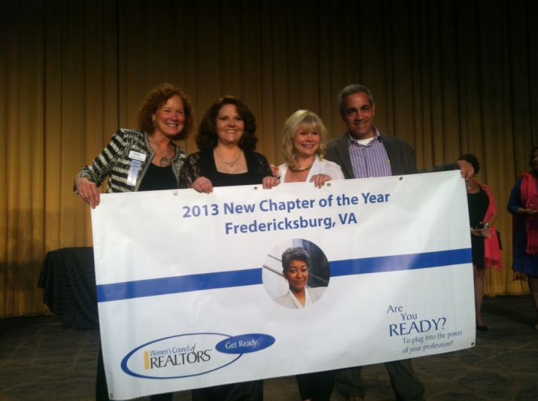
- Blake Hegeman (VAR Legal Counsel) providing insight on Risk Management for Social Media (CE credit offered)
- Silent Auction to benefit Thurman Brisben Center – raised over $2500.
- Fashion Show at Chico’s showcasing professional and casual styles
- A panel of local homebuilders
JOIN ONLINE
AT
WWW.WCR.ORG

Join us the second Monday of each month from 12:00-1:30 p.m. in the FAAR classroom. A light lunch is provided.
Contact Lori Feldhaus, Membership Chairman, for more information –
540-809-2088 or lfeldhaus@assist2sell.com
BEST WAY TO JOIN!!

Or join online at http://www.WCR.com

Like us on Facebook! https://www.facebook.com/groups/FredericksburgWCR/

ANNUAL DUES OF $171.00 PROVIDE PROGRAMS OF VALUE, NETWORKING OPPORTUNITIES, LIGHT LUNCH, AND PROFESSIONAL DEVELOPMENT!
2014 Officers
President – Sandy Pearce (Coldwell Banker Elite)
President-Elect – Michael Straley (Fathom Realty)
Immediate Past President – Rebecca Straley (Fathom Realty)
Treasurer – Kay Burleson (Realty Solutions Burleson Group)
Secretary – Mary Beth Rich (Century 21 New Millenium)
Membership Chair – Lori Feldhaus (Assist2Sell)

Upcoming Programs:
July 10 – Build Day at Habitat for Humanity Women Build Site
August 10 – Pool Party at the Straleys – Day of Fun & Sun
September 8 – Fashion for the Professional – Meeting Held at Chico’s
October 13 – Personality Profiling & Election of Officers for 2015
November 13 – Installation of Officers for 2015 w/ Guest Speaker Terrie Suit, CEO of VAR
December 8 – Community Outreach/Day of Sharing – Secret Santa and Potluck

Meetings & Events:
Chapter Meeting: Second Monday of every month EXCEPT July
12:00 noon to 1:30 p.m.

Chapter Meeting Location: Fredericksburg Area Association of Realtors Building
2050 Gordon Shelton Blvd., Fredericksburg, VA
Governing Board Meeting: Immediately preceding each chapter meeting & is open to anyone
Empower Hour: Fourth Tuesday of each month at Firebirds from 4 to 7 p.m
Open to all members and friends

New Member Orientation: Held twice each year – watch for announcements

