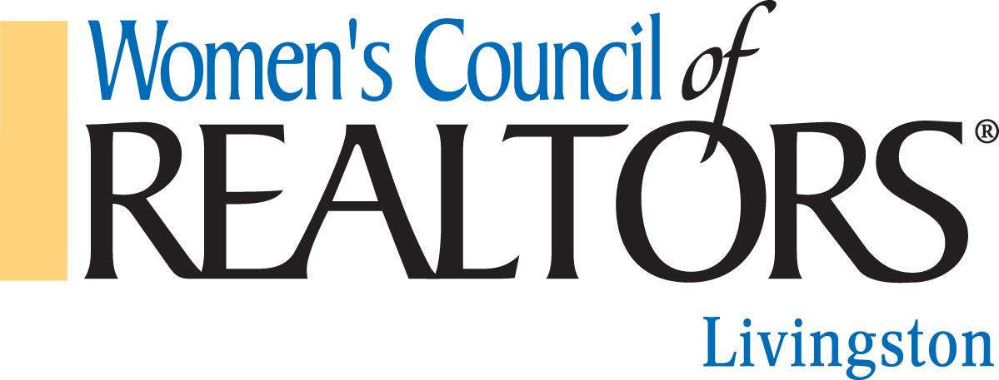
Check Request

Budget Category | Explanation | Receipts (Y/N) | Amount

Requested By: _______________________________________________________________

Check Made Payable to: _______________________________________________________

Need check by this date: _______________________________________________________

Mail Check to: _______________________________________________________________

City: Zip: ___________________________________________________________________

Phone: ( ) _______________________________________________________________

Send Request and All Invoice(s)/Receipts to:

WCR Livingston - Treasurer
Attention: Danielle Boote
100 Orndorf Dr. #1531
Brighton, MI 48116
dboote@danielleboote.com
Approved by: _______________________________________________________________

Check: # Date: ______________________________________________________________

