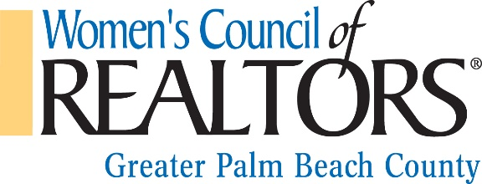
2017 SCHEDULED EVENTS

DATE TIME EVENT LOCATION
THU, JAN 19 11:30 – 2:00 MAKE YOUR BOTTOM BIGGER! MIZNER CC, DELRAY BEACH
JAN 25 – JAN 28 FLORIDA REALTORS ORLANDO
THU, FEB 16 11:30 – 2:00 DON’T LET OPEN PERMITS STEAL… MIZNER CC, DELRAY BEACH
FRI, MAR 24 8:30 – 1:00 BECOME A SOCIAL MEDIA GURU RAPB, WEST PALM BEACH
THU, APR 20 11:30 – 2:00 DON’T LET INSURANCE KILL THE DEAL MIZNER CC, DELRAY BEACH
MAY 18 – MAY 20 WCR/NAR GOVERNANCE MEETINGS WASHINGTON, DC
TUE, MAY 23 5:30 – 7:30 BLUE DIAMOND CIRCLE MIZNER CC, DELRAY BEACH
FRI, JUN 2 DISTRICT III CONFERENCE HUTCHINSON ISLAND
THU, JUN 22 FUN TO BE DETERMINED PALM BEACH COUNTY
JULY NO MEETINGS PLANNED
AUG 4 – AUG 6 WCR LEADERSHIP – PRES.ELECT CHICAGO, IL
THU, AUG 10 5:30 – 7:30 ANNUAL FASHION SHOW LORD & TAYLOR, BOCA RATON
AUG 15 – AUG 20 FLORIDA REALTORS CONVENTION ORLANDO
THU, SEP 14 11:30 – 2:00 APPRAISALS MIZNER CC, DELRAY BEACH
NOV 1 – NOV 5 NAR/WCR NATIONAL CONFERENCE CHICAGO, IL
THU, NOV 16 11:30 – 2:00 ACCOUNTING FOR YOUR $$ MIZNER CC, DELRAY BEACH
TUE, OCT 24 6:30 – 8:30 BRAS FOR A CAUSE OLD SCHOOL SQUARE, DELRAY BEACH
DECEMBER 2018 OFFICER INSTALLATION TO BE DETERMINED

YELLOW – BUSINESS RESOURCE MEETING
BLUE – EVENT
GREEN – FUND RAISER

