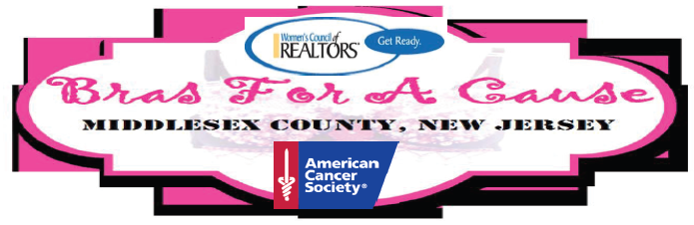
Sept. 23, 2016, 6 – 10 PM at the Portuguese Social Club 100 John St, South River NJ
2016 SPONSORSHIP FORM
NAME:___________________________________COMPANY:___________________________________
ADDRESS:_________________________________CITY_____________________ STATE___ ZIP:_______
EMAIL:___________________________________PHONE:__________________ ___________________
Name as you would like it to appear on sponsorship materials: ___________________________________________
_____________________________________________________________________________________
FRIENDS Our BFAC Event Sponsors acknowledged before, during and following our Event
Level | Sponsor-ship | WCR Website | Program Ad Copy | Press Release | Your Banner | # Event Tickets | Select One
Platinum | $1000 | ● | Full Page | ● | ● | 6 | [ ]
Gold | $750 | ● | Half Page | ● | ● | 5 | [ ]
Silver | $500 | ● | Quarter Page | ● |  | 4 | [ ]
Bronze | $250 | ● | Eighth Page | ● |  | 2 | [ ]
_____________________________________________________________________________________
BRAS by Friends Our Sponsors & Contributors of Individual BRAs for Auction (listed on Program)
OUR BRA For A Cause | $150 | Our Theme & Costume (many available themes & costumes)  Our Help w/ Yours [ ] and also need a Model [ ] | [ ]
YOUR BRA For A Cause | $125 | Your Theme* & You Create Costume  You Recruit Your Own Model** | [ ]
_____________________________________________________________________________________*Themes to be Ok’d by WCR | **Male Models only please

Your BRA Theme & Title:
Your BRA Model’s Name: |  | Phone# ( )
WCR Notes:
All sponsorships are due at commitment by Check Made Payable to “WCR”
Mail payment to – BRAS c/o Women’s Council of REALTORS® PO Box 4452 Metuchen, NJ 08840
For more information email us at MiddlesexWCR@gmail.com (in subject include “BFAC Event Committee”) or Call Ana Monroy at 732-718-6929. Addition posts on www.WCRNJ.com under Events.

2015 MIDDLESEX COUNTY CHAPTER OF WCR BRAS FOR A CAUSE (BFAC) EVENT

