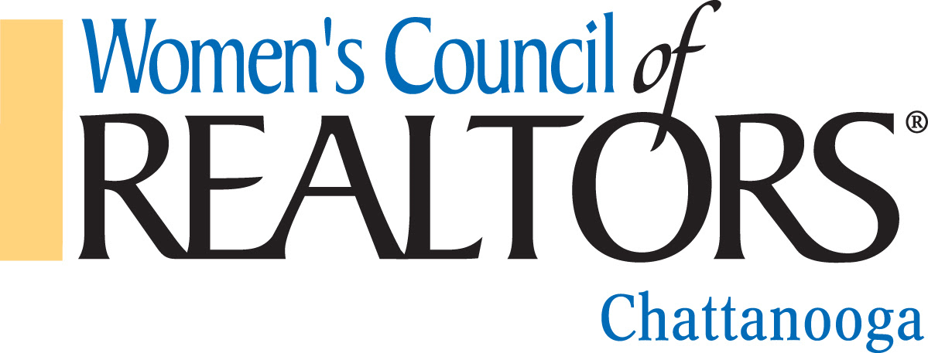

SCHOLARSHIP SPRING CONFERENCE PROGRAM
$250.00

The purpose of the Scholarship Program is to promote career development and leadership skills. Qualified award will assist the Women’s Council of Realtors® Chattanooga member in their pursuit of leadership skills.
Scholarship will be awarded on the basis of reimbursement for attendance at the Tennessee Realtors Spring Conference, March 19-20, 2018 in Cool Springs.

Any Women’s Council of Realtors® Chattanooga Realtor® in good standing whose dues are current may apply for drawing, upon verification of qualifications. (Receipts for: hotel, conference) Current Governing Board members are not eligible for Scholarship.

All applications must be submitted NO LATER than March 31st to the Membership Director, Connie Brewer of Women’s Council of Realtors® Chattanooga for verification.

Scholarships will be awarded at the April Program and winner must be present for drawing at April Program.

Name: _______________________________________________________________________
Email Address: ________________________________________________________________
Phone: _________________________________________
Date Joined Women’s Council of Realtors® Chattanooga: _______________

