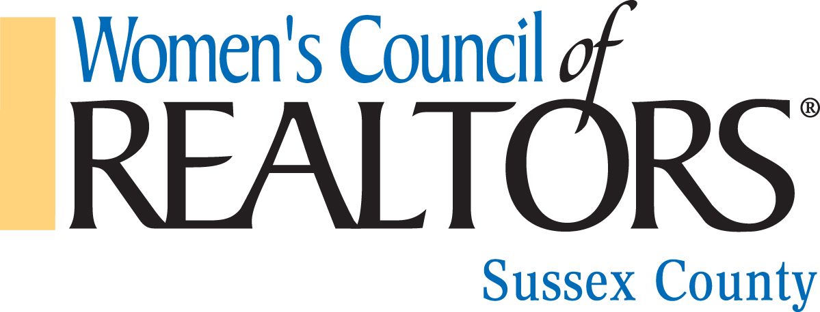

UPCOMING EVENTS

OCTOBER 14 2018
MURDER MYSTERY – DIA DE LOS MUERTOS
FAIRFIELD INN/MARRIOT
19113 COASTAL Hwy, REHOBOTH BEACH

OCTOBER 16, 2018
CE CLASS – Real Estate Jeopardy
VICTORIA’S RESTAURANT
Olive Street, Rehoboth Beach, DE
General Membership Meeting 11-Noon
Lunch 11:30
CE Class Noon – 3pm

NOVEMBER 15, 2018
INSTALLATION OF 2019 GOVERNING BOARD
Special Guest Rose LaPira
Women’s Council of Realtors Region 6, 2019 President

DECEMBER 4, 2018
The Strategic Partner Appreciation Luncheon
&
Our Network 10th Anniversary Celebration
Honoring our Past Network Presidents.
11:30-2pm Victoria’s Restaurant
Rehoboth Beach, DE

