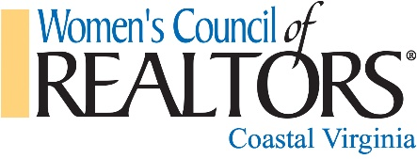

Women’s Council of REALTORS® - Coastal Virginia Schedule for 2017

Membership Monthly meetings (9:30-11:00) – at VPAR unless indicated otherwise
- January 12th – General Membership meeting
- February 22nd – “Networking & Referrals: Building Business Profit” with Go Straley Seminars
- March 9th – “Goals, Smart & Generic” with Shelly Smith of Premier Rapport
- April 13th – “Business Trends” with James Koch, ODU
- May 11th @ James River County Club – Fundraising Event
- June 8th – General Membership meeting
- July 13th @ Founders Pointe – Christmas in July – Wine Cellar Fundraiser
- August 10th – “Hoarding” with Mally Dryden-Mason, DPOR
- September 14th – General Membership meeting
- October 12th @ “Social Media” with Atlantic Bay
- November 9th @ VPAR – “Cultural Awareness”
- December 14th - Bottle Auction Fundraiser
Monthly Governing Meetings (9:00-11:00) – 1 Old Oyster Point Rd., Ste 210
- January 5th
- February 2nd
- March 2nd
- April 6th
- May 4th
- June 1st
- July 6th
- August 3rd
- September 7th
- October 5th
- November 2nd
- December 7th
Misc. State Chapter Meetings & National Conferences
- February 7-9 VAR Legislative Conference & WCR State Meeting - Richmond
- May 18-20 NAR/WCR Midyear Meeting – Washington D.C. Hilton
- July 16-18 Region 1 Conference – Stonewall Resort, Roanoke WV
- August 4-6 WCR Leadership Academy – by invitation only - Chicago
- October 3-5 WCR State Meeting – Hotel Roanoke & Convention Center – Roanoke, VA
- November 1-5 NAR/WCR National Conference – Palmer House Hilton - Chicago

