Metro South | September 2016 • Volume 1, Issue 9
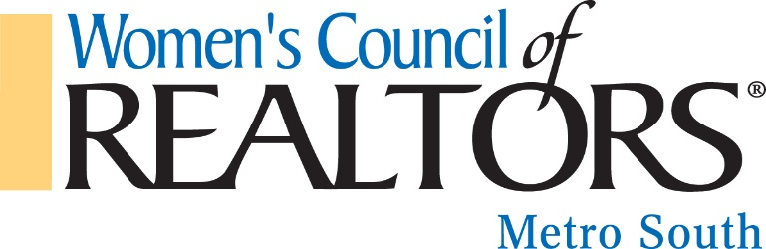
Mission:
We are a network of successful REALTORS® empowering women to exercise their potential as entrepreneurs and industry leaders.

VISION STATEMENT:
Through our influence as successful business professionals, women will effect positive change in the profession and in the broader community.

Governing Board  President  Tammy Noll  Oliver Adams Realty, LLC  President-elect  Brande Smith  Market South  VP, Membership  Amy Hudgins  Apple Realty, INC  Secretary  Standish Ponder  Crowe Realty  Treasurer  Dean Bendall  HomeBridge Mortgage  Membership Chair  Les Lane  Market South  Finance & Budget Chair  Carole Hodge  Wells Fargo  Marketing Chair  Angela Ham  Keller William Realty Atlanta Classic  Education Chair  Michelle Griffin  Preferred Realty Partners, LLC  Ways & Means Chair  Karen Devonshire  Sparks/King/Watts Law Firm  Hospitality Committee  Wanda Stoy  Light House Inspections  Awards & Recognition  Gloria Easler  Southside Realtors | September Business Resource Meeting  Featuring: When all else fails remember to S.I.N.G.  Location: Pinehurst Event Center  108 South Lee Street  Stockbridge, GA 30281  Cost: $10 per member; $15 non-member  RSVP Very Important email nolltammyj@gmail.com  September is Self Defense Month.  September is Self Defense Month and we have two amazing speakers, but they will do more than speak so come prepared to learn some moves that may very well save your life in the event you find yourself in a situation that requires fast, precise moves. Also hear the latest legal updates and concealed carry laws and the use of force laws.  B.J Monti from the Henry County Police Department  Ted Manolis, Self Defense Instructor  Thank You to Our September Sponsors!  Alisha Anderson  Wanda Stoy  Karen Devonshire  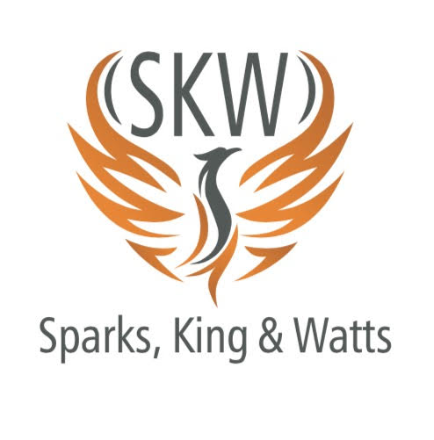  NEW MEMBER ORIENTATION  If you joined Women’s Council and have not attended New Member Orientation.  Then this is for “YOU”  Monday October 17th 6:30-8:30pm  Logan Roadhouse Garage.  20 Mill Road McDonough GA 30253  Please RSVP to Amy Hudgins  678-414-2978 amyhudgins@bellsouth.net Les Lane 770-756-7355 leslanesells4u@gmail.com  October 4th Our Guest Speakers will be The Furious 5  Deborah Gilmore – 2010 National President, Women’s Council of REALTORS®  Faith Reid –2016 Regional VP Women’s Council of REALTORS®  Veronica Bangsboll – Governor & 2015 President Women’s Council of REALTORS®  Jo Kenney – 2014 National President, Women’s Council of REALTORS®  Joyce Turner- 2016 Georgia President Women’s Council of REALTORS®

October Events

October 4th Metro South Women’s Council of REALTORS® Business Resource Meeting.

October 8th The REALTORS® Code of Ethics CE 3 credit hours, Board Office Morrow.

October 12th Trade Show (Go to www.msar.org for details and times).

October 17th New Member Orientation Logan’s Roadhouse 6:30-8:30 pm.

October 22nd Women’s Council “Chili Cook off & Family Fall Festival”
More details to follow…We need members to volunteers to help with this event if you are interested please stay after our meeting today along with your leadership team.

GAR - Georgia Association of REALTORS® UPDATE

During the GAR Convention in Destin Fla the State Women’s Council Membership Meeting was held and your 2017 Line Officers were voted into office.

Congratulations! To your 2017 Leadership Team for the State of Georgia Women’s Council of REALTORS®.

Charlene Faucett – 2017 President
Monica Spillane – 2017 President Elect
Tammy Noll – 2017 Secretary & 2017 National Steering Committee
Shavon Echols – 2017 Treasure & 2017 National Steering Committee
Joyce Turner- Immediate Past President & Governor

Future Meetings

Oct 4th Speakers: The Furious 5

November 10th Speaker: Affiliate Appreciation

December 12th Speaker: 2016 President Farwell & Installation of 2017 LEADERSHIP.
Also Awards Ceremony conducted by Gloria Easler.

