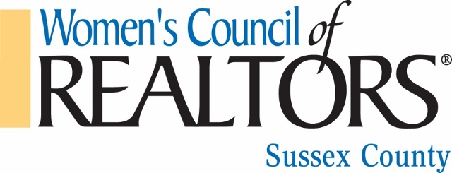

Sussex County Chapter  Delaware  Mission  We are a network of successful REALTORS® empowering women to exercise their potential as entrepreneurs and industry leaders.  2018 Chapter Leaders  President  Marjorie Eckerd  Joe Maggio Realty  marjie.eckerd@gmail.com  President-Elect  Sue Sisson  Joe Maggio Realty  suesis@msn.com  Membership  Joe Della Torre  Union Home Mortgage  joe@unionhomemortgage.com  Program Chair  Tammy Rust  Mann & Sons Realty  realtortrust@gmail.com  Secretary  Maria C. Bennett  Joe Maggio Realty  mariacbennettrealtor@gmail.com  Treasurer  Patti LaRosa  Union Home Mortgage  plarosa@unionhomemortgage.com  Governor  Deborah Cobb  Long and Foster Real Estate  Deborah.Cobb@lnf.com  Past Presidents  2017 – Debbie Cobb  2016 - Sandi Bisgood  2015 – Kathy Douglass  2014 – Carol Wayne  2013 – Ruth Sivils  2012 - Joanie Hannigan  2011 - Beth Dorman  2010 – Ginny Hysock  2008/2009 – Paula Castiglione | April 3, 2018  Greetings Everyone,  WOW! We have survived our first quarter with a very “newbie” line of your officers. Great instructions from Debbie Cobb, Brad Riedle, Beth Dorman and past presidents who, at the onset, gave us the impetus to move ahead.  We can report 4 superb Membership Mixers where many of you attended and re-joined or joined our Network. Please keep up the support.  Under the new guidelines from National Women’s Council of Realtors, we will be implementing the required 4 Board Meetings and 6 General  Membership Meetings this year. Look forward to interesting Speakers,  C.E. Classes and a special required Industry Event, as the year progresses.  We are keeping our fundraiser, newly named “Mardi Bras” in June. Our Ways & Means Committee is researching more avenues to raise the funds needed to bring you programs you will be proud to attend and share.  Much are we aware that we cannot achieve and maintain a strong Network without the support of our 2018-2019 Strategic Sponsors and Partners: You are so appreciated, thank you.  The Governing Board hopes to see all of you at some point this year.  Meet us! Enjoy us! Join us!  Marjorie Eckerd, President 2018  P.S. Attached are articles that highlight six of our Strategic Sponsors and  their service to the real estate industry.

