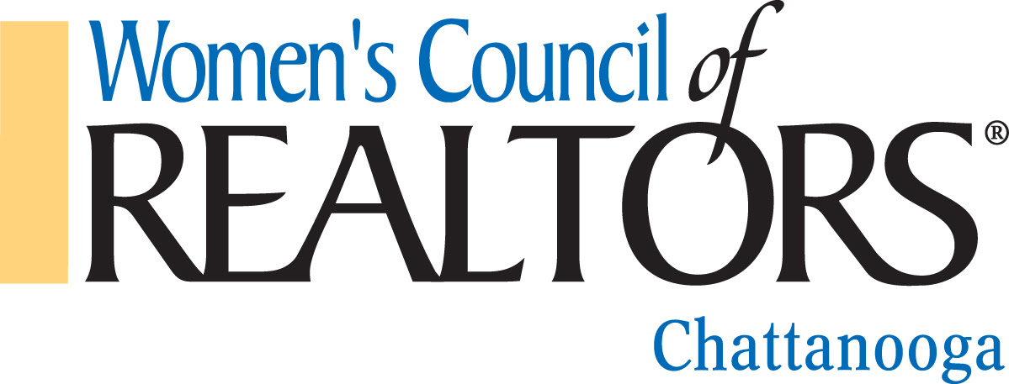

SCHOLARSHIP INCENTIVE
TENNESSEE REALTORS FALL CONFERENCE 2018

The purpose of the Scholarship Incentive is to promote career development and leadership skills in our members. The qualified award will assist the Women’s Council of Realtors Chattanooga recipient in the pursuit of these goals.

A drawing for reimbursement of expenses up to $500.00 will be awarded to one Women’s Council of Realtors Chattanooga Realtor Member and/or National Member in good standing whose dues are current. To be eligible for the drawing, you must attend the Tennessee Realtors Fall Conference, September 12-14, 2018 in Knoxville. Current Governing Board members are not eligible for Scholarship.

All applications must be submitted NO LATER than September 30th to the Membership Director, Connie Brewer, at cbrewhomes@gmail.com. Receipts for verification of attendance (registration, hotel and ancillary travel expenses) must accompany this application.

The drawing for the scholarship will be held at the Business Network Meeting on October 3rd, 2018, at the Walden Club and the recipient must be present to win.

Name: _____________________________________________________________

Email Address: ______________________________________________________

Phone: ____________________________________________________________

We are a network of successful REALTORS®, advancing women
as professionals and leaders in business, the industry and the communities we serve.

