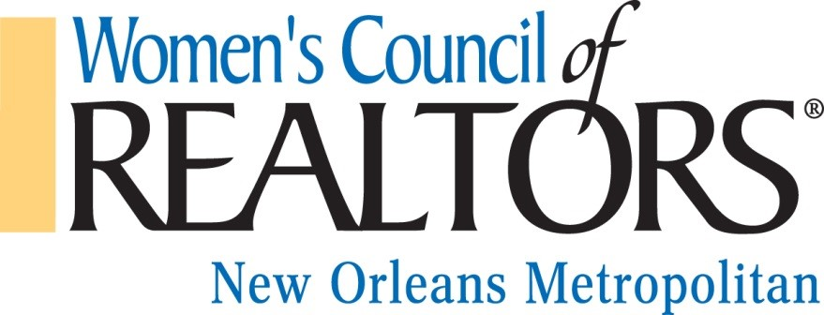

LOCAL NETWORK CONSENT TO SERVE & CANDIDATE APPLICATION

I agree to serve as a Governing Board member of the Women’s Council of REALTORS® New Orleans Metropolitan for 2018. I acknowledge and accept my fiduciary obligation to act in the best interests of the Network as follows:

1.) Duty of Care: I will use the care that a reasonably prudent person would exercise in a like position and under similar circumstances. This means that I agree to attend
meetings, ask questions to gain information I reasonably need to make a decision and exercise independent judgment.

2.) Duty of Loyalty: I will advance the best interests and well-being of the Network over any individual or local interests, and I will refrain from using my position of trust to
further my own interests in a way that conflicts with the interests of the Network.

3.) Duty of Obedience: I will accept, support and implement Governing Board decisions, even if I voted against them. I will follow the Bylaws of the Network and comply with all Standing Rules relating to Network activities.

4.) Travel & Time: I understand the time and travel requirements for the position that I have been elected/appointed to serve. I may need to fund myself, depending on network budget for this travel. I will make every effort to give of my time to meet the requirements of this position.

5.) Duty of Confidentiality I will not speak or act for the Network unless specifically authorized to do so. I will not present opinions about Network business unless these opinions are clearly expressed as personal opinions not necessarily the views of the Network.

My signature below acknowledges that I agree to be bound by the terms of consent above.

Signature: _________________________________________________ Date: __________________________

Local Network Candidate Application

Name: ___________________________________________________________________________________
Designations: ______________________________________________________________________________
Firm: _____________________________________________________________________________________
Address: __________________________________________________________________________________
Cell Phone: ______________________________ Email: ____________________________________________
Current Position, if any, at Women’s Council of REALTORS®: ______________________________________
__________________________________________________________________________________________
Applying for elected positions: President-elect: _______ *Treasurer: _______
Interested in appointed positions: *Membership Director: _____ Program Director: _____ Secretary: _____
Other appointment(s) of interest: _________________________________________________________
__________________________________________________________________________________________
(*National Affiliate Members eligible for Treasurer and Membership Director)
Answer Yes or No to following questions. Circle or underline your answer.
- Yes / No Are you a REALTOR® or REALTOR®-Associate in good standing with a local Board/Association of REALTORS®?
  - Attach documentation of membership in good standing from Board/Association.
- Yes / No Are you a National Affiliate Member in good standing with a local Board/Association of REALTORS®?
  - Attach documentation of membership in good standing from Board/Association.
- Yes / No I Commit to attend Board meetings, appropriate Project Team and Women’s Council Events and Programs.
- Yes / No I have read the job description for this position and am qualified to be a candidate.

Signature: _________________________________________________ Date: __________________________
MUST be returned to Candidate Review Team Chair no later than 30 days prior to election date.

