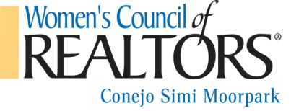
BUSINESS RESOURCE MEETING SPONSOR
As a Business Resource Meeting Sponsor ($200):
• Special Recognition in the Program with Logo, Company name, website, contact number.
• Special Recognition on Facebook Page
• Ability to have a table for your materials prominently displayed
• Ability to pass out materials at each place setting.
• Introduced from podium at meeting. Time to speak at meeting 2-3 minutes (educational/informational about your service or product)
Meeting & Date ____________________________________________
Choose your group (Must be one of these already.):
◻ Realtor member ◻ National Affiliate member ◻ Strategic Partner ◻ Corporate Partner
Name: _______________________________________________________________
Company name: _______________________________________________________
Phone number (1): _____________________________________________________
Email _______________________________________________________________
Category/type (ex. lender, home warranty, etc.) ______________________________
Payment by credit card can be arranged. Please contact us for details. Please complete the above application with a check payable to Women's Council of Realtors and mail to:
Women’s Council of Realtors
c/o Simone Yallouz, Treasurer
Planatek Financial
340 N. Westlake Blvd Ste 240
Westlake Village, CA 91362
If you have any questions, please contact our Sponsorship Chair, Carol Salgado 818-631-5554 (cell) or CSalgado@lfcu.com. Or, President Tamara Campbell, 805-750-6577 (cell) or Tamara@CallTamara4Homes.com.
Thank you for your continued support!
Rev.12/1

