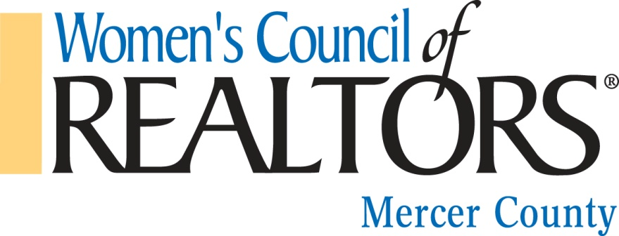
2019 Strategic Partner Agreement
I ____________________________________________(primary contact)
Business____________________________________________________

Considered my business for membership to the to the Women's Council of Realtors Mercer County Network Strategic Partner Program for the year_________________.
Terms & Conditions
Strategic Partners Agree to: Please initial
____ I agree to fully participate and proactively engage with the Women's Council of Realtors Mercer County Network Membership and Prospective Members to maximize business potential.
____ I agree to actively promote the Women's Council of Realtors Mercer County Network to my network of contacts making them aware of the benefit of membership and informing them of local Women's Council of Realtor Mercer County Network Events.
____ I agree not to schedule events that may conflict with the Women's Council of Realtors Mercer County Network Events. When in doubt I will contact the Governing Board.
____ I agree to provide my company logo and PDF of my business card or current contact information to the President of the Women's Council of Realtors Mercer County Network.
____ I agree to attend every local event when possible; networking, displaying and handing out my business card and promotional material.
___ I agree to respond to Women's Council of Realtors Mercer County Network e-mails, meeting invitations, within a 24 hour business standard and to adhere to deadlines as required.
____ I agree to respond in a timely business manner to the Annual Fundraising Event Project Team by participating in the Annual Fundraiser by choosing my contribution among the choices and levels provided.
___ I agree to offer constructive feedback and communicate ideas and opportunities to enhance my experience as a Strategic Partner to the President or Strategic Partner Governing Board Representative.
___ I agree that if I do not meet my financial obligations to the Women's Council of Realtors Mercer County Network my Strategic Partner status and privileges may be revoked by the Governing Board.
___ I certify that I have not been convicted of any act that has been adjudicated which would cause or has caused temporary or permanent suspension of my license in the profession for which I am applying
Name of Company/Business: ____________________________________________________
Business Address:______________________________________________________________
City__________________________________/ State_____________________/ Zip__________
Business Phone & Ext.:__________________________/ Mobile Phone: ___________________
Fax:_______________________________
E-Mail: _______________________________________________________________________
Business Category: ______________________________________________________________
Business Description: ____________________________________________________________
_____________________________________________________________________________
____________________________________________________________________________
Signed: _____________________________________________/Date____________________
Please return by e-mail to the Women's Council of Realtors Mercer County Network President by 1/9.

