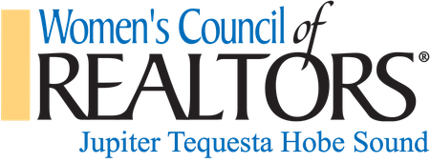 |  | 2019 Annual  Strategic Partner  Opportunities from  January 1 – Dec 31, 2019
Annual Benefits and Tier Levels | Platinum ∼ $750 | Gold ∼ $500 | Silver ∼ $250
Complimentary Admission to Business Resource Meeting (BRM) | 6 | 2 | n/a
Company representatives | 2 | 1 | 1
Two (2) minute presentation at BRM which includes promotional materials outside of room while greeting guests | 2 | 1 | n/a
Local affiliation to WCR JTHS which includes access at member discount price | ♥ | ♥ | ♥
Recognition on WCR JTHS promotional materials disbursed at BRM | ♥ | ♥
Business promotional materials may be displayed on advertising table at BRM | ♥ | ♥
Recognition on Jupiter Tequesta Hobe Sound Network website as 2019 Local Strategic Partner | ♥ | ♥
Logo Placement on WCR JTHS Banner | ♥  Larger Image | ♥
Hyperlink to company website from WCR JTHS website | ♥
First opportunity to sponsor educational events you moderate | ♥

