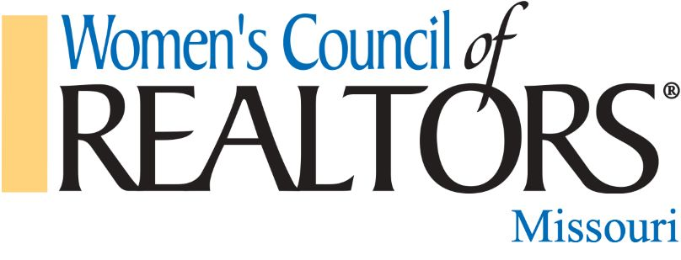
2020 State Programs
January 22nd “Put Your Finger on the Pulse” with John M Sebree. Missouri REALTORS® CEO and Elizabeth Mendenhall, 2018 National Association of REALTORS® President

April 22nd Brenda Oliver, 2003 President Women’s Council @Missouri and 2019 President Missouri REALTORS® “What to expect when you go to Capitol Conference and the Bills that Affect Us”.

September 16th Janet Judd 2020 President Elect Missouri REALTORS® and Donny Allen will present a CE class on Safety.

