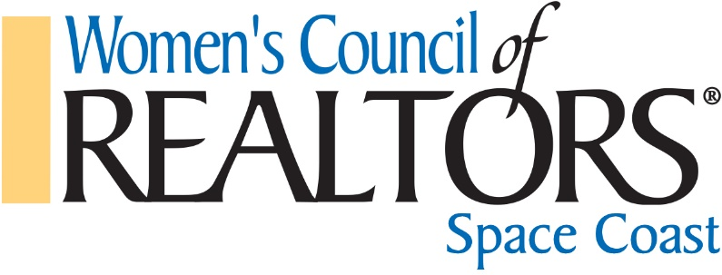
Past Presidents

2019 Lynda Austin
2018 Theresa Bassing
2017 Peggy Hall
2016 Susan Kuschel
2015 Joanna Starr Hynes
2014 Bree Fary, Joanna Starr Hynes
2013 Nora Marek
2012 Meg Scott
2011 Meg Scott
2010 Laura Hazlett
2009 Joanna Starr Hynes
2008 Barbara Van Dam
2007 Claudia Clausen, Barbara Van Dam
2006 Pat Brickner
2005 Kristen Saunders
2004 Evelyn Murray
2003 Amy Roberson
2002 Janet Helms
2001 Ruth Schechter
2000 Mary Crawford
1999 Mary Crawford
1998 Mischel Ostovich
1997 Gail Pearson
1996 Sherrie Quarrie
1995 Margaretta Kemmler
1994 Kay Buchanan
1993 Stephanie Dilpare
1992 Sue Sorenson
1991 Nancy Smallembroek
1990 Dene Weimer
1989 Jean Rubin
1988 Phyllis Smith
1987 Mary Selig
1986 Alma Porter
1985 Marge Williams
1984 Marge Williams
1983 Ruth Schechter
1982 Pauline Sharrock
1981 Pauline Sharrock
1980 Jean Gardner
1979 Mary Poytner
1978 Mary Poytner
1977 Carole Jowers
1976 Carole Jowers
1975 Lorraine Rhearns
1974 Gloria Gardner
1973 Katherine Doran

Previous Network names: Brevard Network, Brevard Chapter and Brevard County Chapter.

