2021 Women’s Council of Realtors Lake Pointe Local Strategic Partner Membership Application and Sponsorships

MEMBERSHIP ANNUAL DUES: LOCAL STRATEGIC PARTNER $110.00
SILVER SPONSOR $250.00 GOLD SPONSOR $500.00 PLATINUM SPONSOR $1000.00 Please fill out this form and return as indicated below.
New Member Membership Renewal - be sure to fill out contact info
Name__________________________________________________________________
Title___________________________________________________________________
Company_______________________________________________________________
Address:_______________________________________________________________
Off Phone____________________________ Cell Phone:________________________
E-Mail: Address_________________________________________________________
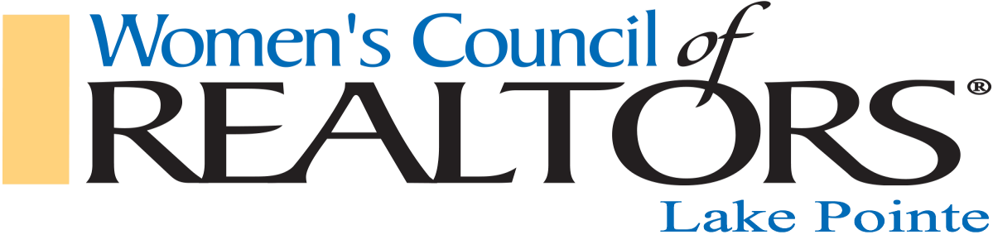
Website:_______________________________________________________________
Any other info:__________________________________________________________
If paying by Check, please make payable to: Women’s Council of Realtors Lake Pointe
Mail to: Franny Kanalos, 53012 Springhill Meadows, Macomb Twp. MI. 48042
Credit Card Pymt: Please complete, sign and e-mail as PDF to: frannyksells@gmail.com
- I authorize $_________________to be charged
- Credit Card #__________________________________________________________
- Expiration Date________________________________________________________
- CRV#________________________________________________________________
- Name on Card________________________________________________________
- Billing Address________________________________________________________
- Signature authorizing payment___________________________________________

Upon receiving your application we will e-mail you our calendar of events and when the next Lake Pointe member orientation will be. We look forward to partnering with you in
2021. If you have any questions please e-mail LakePointeWomensCouncil@gmail.com

