WOMEN’S COUNCIL OF REALTORS LAKE POINTE
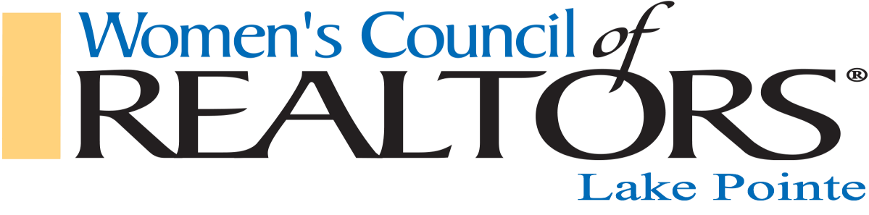
2021 ANNUAL SPONSORSHIP PROGRAM OPPORTUNITIES
Building Leaders one Member at a Time

For January - December 2021 SILVER GOLD PLATINUM
Levels $250.00 $500.00 $1,000.00
Incudes 2 membership
X
Name listed in Lake Pointe Partner's Brochure X X X
Name listed on Flier displayed on tables at ALL Lake Pointe Events X X X
Any non-member brought as your guest will be charged mem pricing X X X
Mailing List of Attendees at Lake Pointe Events X X X
Company materials on display table at Industry (4) & Network (2) Events X X X
Complimentary Admission to all WCR State Meets. X X X
Table for representative, marketing materials at all Events X X X
OPPORTUNITY TO SPONSOR A MIXER EVENT FOR $200
X X X
Opportunity to join State Committee to coordinate Network Events X X X
Company materials on display table at Network Events (at least 2) X X X
Partner badge to wear to Network Events X X X
Company materials in WCR Swag bag given to members X X X
Promo article on your business X x
Professional "Proud WCR Partner" Signage displayed at all events X
Logo Displayed on Lake Pointe Website X
Three minute mic time at Lake Pointe X
Company Logo displayed on professional banner X

The Lake Pointe Network offers our Strategic Partners the opportunity to Sponsor our Lake Pointe Mixers for $200.00 per Mixer Event.
Please contact Franny Kanalos,
Director of Membership
586 243-1533
frannykselss@gmail.com

--
-

