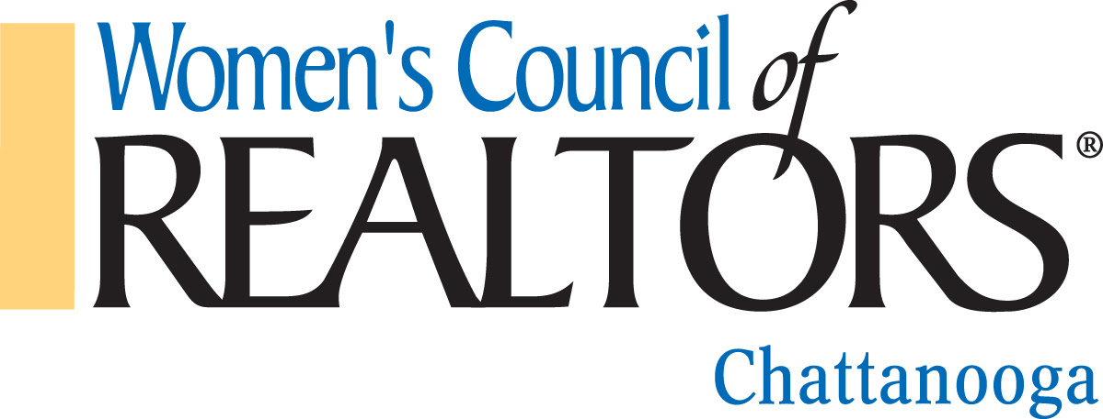
Get Reimbursed for Education

It's October?! — Yes: Join us Oct. 12-14
Fall Scholarship - Chattanooga Network

Our Tennessee Realtors 2020 Virtual Fall Convention, begins next week October 12, 2020, via Zoom, will feature inspiring guest speakers, daily CE sessions, statewide awards, officer installations, our Board of Directors meeting, and more. The regular sessions' cost is free for non-CE attendees and only $25 per class for each 1 hour CE. (A bargain!) Advance registration is required for all sessions - link is below.
To encourage you to experience this statewide gathering of industry professionals, Active Realtor Members of the Women's Council of
Realtors Chattanooga Network will be reimbursed $25 for completing one of the CE classes (details below).
Additionally, all Chattanooga Network Members completing registration for the convention and visible on Zoom to a board member will be entered into a drawing at our November 4th meeting for 1 of 2 $50 Gift Cards, must be present to win.
To be eligible for both the reimbursement and the drawing: Submit a copy of the detail page from your license verification https://apps.tn.gov/licenses/ showing the hour credit applied to your record together with a reimbursement form that we will supply, and/or a copy of your convention registration form. The Chattanooga Network will not duplicate funding or reimbursements available from other Real Estate Boards or organizations. Email all paperwork to wcrchattanoogarocks@gmail.com or hand deliver to the November luncheon. Or contact a board member.

Register HERE. (Member login required) or go to TNRealtors.com/FallConvention
You'll need your NRDS ID & TN LICENSE NUMBER to create an account or to reset your password at Tennessee Realtors.

Mission Statement:
We are a network of successful REALTORS®, advancing women as business leaders in the industry and in the communities we serve.

