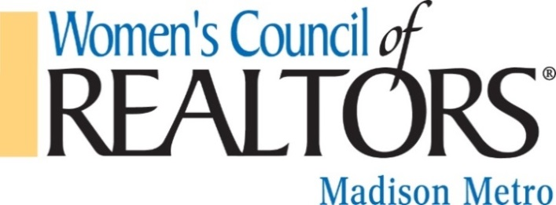
Mail form and payment to:
Women’s Council of REALTORS®
PO Box 259515
Madison, WI 53725
(Please make check payable to Women’s Council of REALTORS® Madison Metro)

2021 Strategic Partnership Opportunities
- Platinum Level Strategic Partner - $1,000-Now $500
- Gold Level Strategic Partner - $750-$375
- Silver Level Strategic Partner - $500-$250
- Bronze Level Strategic Partner - $200-$100

Name of Designated Partner attending Network events: __________________________________________

2nd Designated Person (if applicable):_________________________________________________________

Company: ______________________________________________________________________________

Address: _______________________________________________________________________________

Phone: _________________________ Email:_________________________________________________

Payment Method:
Please email an invoice to: ______________________________________________________________
Check made payable to Women’s Council of REALTORS® Madison Metro is enclosed.
Please charge my VISA MasterCard Discover Card

#:_____________________________________________________________________________________

Exp. Date: _______________________ 3-Digit Security Code: ____________________

Billing Address for the credit card:____________________________________________________________

Mail form and payment to:
Women’s Council of REALTORS®

PO Box 259515

Madison, WI 53725
**If sending a check, please make payable to Women’s Council of REALTORS® Madison Metro
Thank you for your partnership!!

