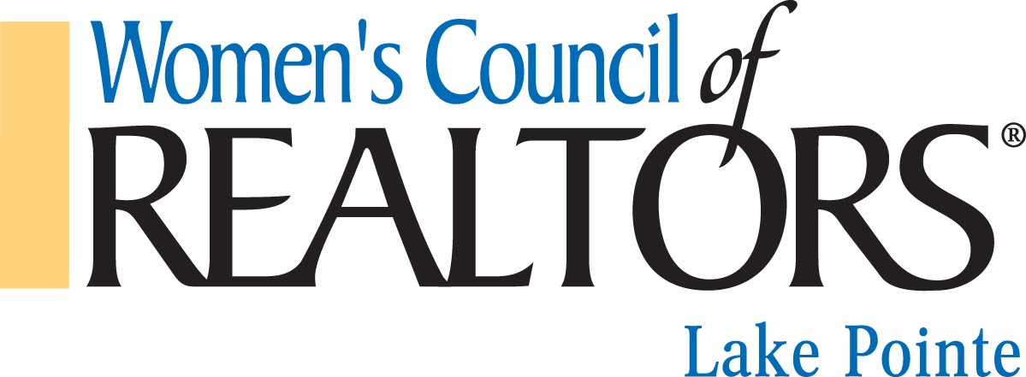

Lake Pointe Board Meeting

March 2, 2021 9 am

This meeting was held virtually.

**Present**: Pat Dery, Randi Brandt, Alicia Beasley, Franny Kanalos, and Kathleen Kelchner (9:38a

**Absent**: Jamie Begin, Jackie Warner, Veronica Kanalos and Alyssa Fuller.

**Guest:** Lori Jaglois

Meeting was called to order at 9:05 am by President, Pat Dery

Agenda was presented and approved.

Minutes from the February 2, 2021 board meeting reviewed and approved.

***Reports***:

**President:** Pat Dery asked for nominees for the Nomination Project team. An email was received from Cindy Mancerio that she is interested in serving on the team. Kelly Dix has agreed to be on the team. No other names were submitted. Pat will call some members, we need at least 1 but prefer 2 -3 more members. Pat will give the names to Randi Brandt who will then notify the team and set up a zoom meeting for them. Randi is an ex-officio member of that project team.

Nation Women Council Conference is May 13-15, 2021. It will be virtual. All are expected to attend. If you cannot let Alicia know so she does not register you. It was discussed to have dinner or some type of gathering during this conference.

Pat went over the National Women’s Council Certification form that was emailed to all board members.

We need a project team to go over our Standing Rules. Pat will head that project team.

Charity for 2021 – Meals on Wheels was suggested by Alicia and Motor City Mitten Mission was suggested by Pat. More information on these two organization will be brought to the April meeting.

**President- Elect**: Randi Brandt reported Sajo’s has been booked for our April 21, 2021 Derby Day. It will be from 5:30 p.m. to 8:00 p.m. Cost to members is $25 and this includes appetizers and 1 drink. There will be derby games to play.

**Treasurer**: Alicia Beasley gave a report on the 2021 financials. We have sponsorships from Rick Linnell for $1000 and Caliber Home Loans for $750 and $110 from House calls. Randi needs to get Alicia checks from Weatherstone $750 and FrannyK for $1000. Financials will be filed

Motions from Committee; Send the Lansing Network $185 to pay our portion of the con-ed class. Motion approved. Motion to send our RPAC contribution of $1000. Motion approved.

Alicia will send in the State raffle license request, cost is $50

Alicia reported she is still working on the GMAIL Suites account.

**Director of Membership** Lori Jaglois reported for Franny since she had to leave the meeting. They are working on getting our Strategic Partners signed up and on the 17 members that have not renewed yet.

**Director of Programs**: Kathleen Kelchner reported that flyers will be out for our March Legal class.

We only had 8 members at the ConEd class in February. Alicia confirmed the $500 check was sent to GMAR for our co-sponsorship of the Fair Housing event in April.

**Marketing**: No report

**New Business**:

Pat Dery reported she has been in discussion with August Spree from GMAR on an Annual sponsorship with them. GPPR and Lake Pointe are doing an interchange of sponsorships, no money is changing hands. GMAR does not offer that. There is a $500, $1000, $1500, and $3500 sponsorship opportunity with them. August was checking with their CEO Vicky, Pat will check back her.

Next meeting will be held virtually on April 6, 2021 9am

Meeting adjourned at 10:05 am

Respectfully submitted by,

Pat Dery