+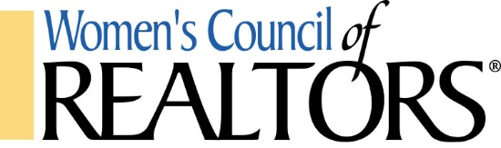

September 2, 2021
Women’s Council of Realtors ®, Lake Havasu City Network Meeting Minutes

Governing Board Meeting – 2:30 – 3:40
Meeting Chair: Trisha Kem, Network President
Officers and Directors: Present – Trisha Kem, Allison Paoli, Mary Johnson, Janace Hartman and Vicki Lind. Absent – Lora Pearce. Guests – Lenea Shaver. A quorum was established.
Secretary, Vicki Lind, stated that June and July minutes were previously approved. August and September minutes will be approved at the October meeting.
Mary Johnson, Treasurer, presented the June ending and June year to date financials. A motion was made, seconded and passed to receive and file for audit. July, August and September financials will be received at the October meeting. Queen of Hearts balance is $710.
Tricia Kem, President – thanked officers for their help while she was out of town unexpectedly.
President Elect, Allison Paoli gave a brief synopsis of Leadership 360 and the State Network meetings she, Cynthia Pearce, Lora Pearce, Kate Olsen and Lisa Cordeiro attended in Scottsdale. Allison is still looking for a Program Director. Of significance is the change from our service years will now be the same as National with next year’s team beginning Nov. 16, 2021.
Lora Pearce, Membership Director, was unable to attend the meeting due to the time shift
Janace Hartman, Programs Director will be working with LHAR this afternoon to finalize the cost for the Carl Carter event today. Next up is the September 16th Sunset Wine Cruise. Members may bring 1 guest, Strategic Partners can use 2020 and 2021 Event tickets. The boat rental will be free due to them cancelling earlier this year which will increase our profits. October 6th will be Leigh Brown. Expected cost will be $40 per person.
New Business: Trisha announced a new program to attract new members. If someone who hasn’t been a member during the last 4 years joins now through the end of the year, they will receive their 2022 dues for free.
Old Business: Trisha will schedule a time with Mary to discuss the Bunco receipts and a donation to a non-profit. An Audit committee composed of Valerie Iorg, Mary Johnson and Colby Steele will meet the week of 9/6.
Good of the Order: None.
Next meeting: October 14, 2021 at Shugrue’s Bridgeview Room
Respectfully submitted,
Vicki Lind, Secretary

