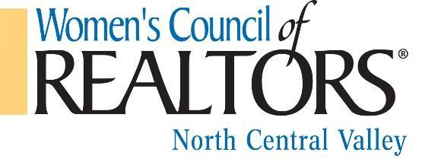

2022 STRATEGIC PARTNER TIERS
LEADERSHIP PARTNER - $5,000 Exclusive Category Partner
● Everything included In Platinum plus Exclusive Category for 1 Rolling Year and Special recognition in Member Only Leadership Training.
PLATINUM - $2,500
- Table for the 2023 Installation Dinner (Valued at $1000)
- Admission for 2 named representatives at ALL events
- Complete mailing list of Network members
- Color logo on promotional materials at ALL events
- Partnership recognition at ALL events
- Includes your company logo on Network website (see www.NorthCentralValleyWCR.com)
- Gain recognition for your company as a supporter with a gift basket donation
- Facebook welcome and company link to Women’s Council website
- Promote your company for 2 minutes at ALL events
- May display your company banner at ALL events (you must supply banner)
- First option to greet guests at sign-in at applicable events
- Company name displayed at each table as part of centerpiece
- May display your company materials on designated table at ALL events
- *All Events=As Applicable. Some events may only allow for verbal recognition, depending on space or venue.
GOLD - $1,500
- Admission for 2 named representatives at ALL events
- Complete mailing list of Network members
- Color logo on promotional materials at ALL events
- Partnership recognition at ALL events
- Includes your company logo on Network website (see www.NorthCentralValleyWCR.com)
- Gain recognition for your company as a supporter with a gift basket donation
- Facebook welcome and company link to Women’s Council website
- Promote your company for 2 minutes at ALL events
- May display your company banner at ALL events (you must supply banner)
- Second option to greet guests at sign-in at applicable events
- *All Events=As Applicable. Some events may only allow for verbal recognition, depending on space or venue.

SILVER - $1,000
- Admission for 1 named representative at ALL events
- Complete mailing list of Network members
- Color logo on promotional materials at ALL events
- Partnership recognition at ALL events
- Includes your company logo on Network website (see www.NorthCentralValleyWCR.com)
- Gain recognition for your company as a supporter with a gift basket donation
- Facebook welcome and company link to Women’s Council Website
- *All Events=As Applicable. Some events may only allow for verbal recognition, depending on space or venue.

BRONZE - $500
- Color logo on promotional materials at ALL events
- Includes your company logo on Network website (see www.NorthCentralValleyWCR.com)
- Gain recognition for your company as a supporter with a gift basket donation
- *All Events=As Applicable. Some events may only allow for verbal recognition, depending on space or venue.
NON-REALTORS - $200 - Admission at member rate for ALL Network meetings, Fundraisers and Members Only programing
What does this look like in a COVID world if we continue all of this online?
WCR North Central Valley is committed to making the MOST of our Partnerships!
Backgrounds for Zoom for each program
Platinum and Gold Tiers continue their “2 minute promotions” to the “Zoom rooms”, we have tested this nationally, and it works great!
WCR NCV will help interview/make on the spot ‘‘commercials’ with our Strategic Partners to post on our Social Media and Website.

