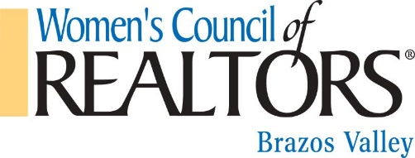
2022 Calendar
JANUARY  1 2022 Dues are to be paid  5-15 State Scholarship Application submission period  7 New Year Kickoff (virtual)  27 Business Planning Workshop by Kelso APM @ Southland Title  2021 Audit | FEBRUARY  1 State Membership Contest begins  3-4 Elevate Summit (virtual)  5-6 Kendra Scott Sale for WCRBV  7 Heirship affidavit vs Probating Wills -UT  10 Women of POWER Day, Austin, TX  11-12 Women’s Council Texas Winter Meeting – Austin, TX  16 12:00pm Central Midyear Meeting Registration Opens  24 Builder’s Roulette @Oakmont | MARCH  14 Foreclosure & REO University Title  24 Big Shots  31 State Membership contest ends  31 2022 Renewal grace period ends. Unpaid members are dropped.  TBD – March Madness Masterminds
APRIL  11 Sold! How to Write Winning Listings University Title  15 State & Local network taxes submitted  TBD Brenham Tour  First Quarter Audit | MAY  3-6 Women’s Council Midyear Meetings  Capital Hilton, Washington, D.C.  9 Facebook 101 Workshop University Title  15 State Newsletter published  26 Texas Land Market Development presented by Charlie Gilleland, TAMU Real Estate Center | JUNE  1-30 Application period open for Leadership Institute 2023  1 State Membership contest begins  13 Class- Who is signing the transaction documents and why University Title  15 Leadership Identification & Development names due to National  16 Card Making Event w/ Milynda Hallermann, America’s Choice
JULY  11 Facebook Marketing University Title  15 State of the Year awards nominations open  15 2023 State Officers nominations open  27-29 Network 360 Leadership Conference Sheraton Grand, Chicago, IL  For all 2023 Presidents  TBD Mistletoe Market Christmas in July  Second Quarter Audit | AUGUST  1 Application period opens for Network Certification Program  8 1031 Exchange  10-20 Texas Scholarship Application submission period  15 State Newsletter published  31 State Membership contest ends | SEPTEMBER  6 Consent to Serve forms due for 2024 National Officers Applications  12 A Dozen Common TREC Contract Problems University Title  14-16 Women’s Council Texas Annual Conference and State Elections  Fort Worth, TX  30 Local Network Officer Elections must be completed  TBD Realtor Safety Gun Course
OCTOBER  TBD 2023 Leadership Orientation  El Paso, TX  10 Local and state networks dues changes due to National for 2023 billing  10 Power of Attorney University Title  TBD Amazing Race - Builders  Third Quarter Audit | NOVEMBER  1 Dues renewals distributed  1 State Newsletter Article Due  9-13 Women’s Council National Conference  Hilton Orlando, Orlando, FL  14 Deeds University Title  15 State Newsletter published  TBD Poker Crawl | DECEMBER  31 Dues expire  TBD Installation of new officers

