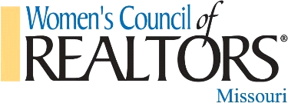

MISSOURI WOMEN’S COUNCIL OF REALTORS MEMBERSHIP MEETING
Tuesday April 26, 2:30 p.m.
#getrealwithwomenscouncil

Welcome & Introductions – State President, Tammy Sherrell-Shortt
RPAC 100% Investment Goal-State President Tammy Sherrell-Shortt
Roll Call – First Vice President, Gerrie Moore
Approval of Agenda –President, Tammy Sherrell-Shortt
Approval of Minutes of January 2022 Meeting – 1st Vice President, Gerrie Moore
- Membership Report – President Elect, Terri Gilgour
- Treasurer Report –Treasurer, Dave Shortt for Denise Pittman
- National and State Update – State Liaison – Lin Van Meter
- Nominating Committee Report-Sandy Grassmuck
- Past President's Advisory Committee, Brenda Oliver
- Local Network updates from Network Presidents
Project Team update
- Ways and Means, Christina Casey and Cortney Stansbury
- Tech and Social Media, Lindsey Helton

Thank you to strategic partners
Adjournment of Business Meeting
Program: Mix and Mingle with our Gold and Silver Sponsors with light refreshments
Gold Sponsor:
Silver Sponsors:

Bronze Sponsors

