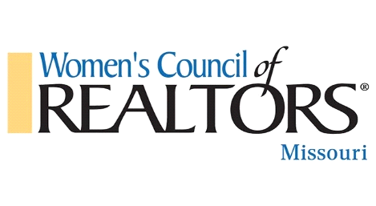
2022 Governing Board Meeting
April 26, 2022, 8:30 AM
Welcome and Introductions – State President – Tammy Sherrell-Shortt
Roll Call – 1st Vice President – Gerrie Moore
Approval of Agenda –Tammy Sherrell-Shortt
Approval of Minutes of January 2022 meeting-1st Vice President, Gerrie Moore
Membership Report – President Elect, Terri Gilgour
Treasurer Report –Treasurer, Dave Shortt for Denise Pittman
National and State Update – State Liaison – Lin VanMeter
Committee Reports:
- Past Presidents –Brenda Oliver
- Strat Planning – Jennifer Langston-Justus & Becky Klein
- Leadership ID and Development-Isabelle Walker
- Bylaws-Edwina Conley
- Nominating-Sandy Grassmuck
Project Teams:
- Ways and Means – Chris Casey, Cortney Stansbury
- Programs & Education– Becky Klein
- Membership-Chrissy Hoerner
- Specialty Groups-Jen Colvin
- Historian – Letty DeMay
- Tech/Social Media-Lindsey Helton
Other Business –
Adjournment

