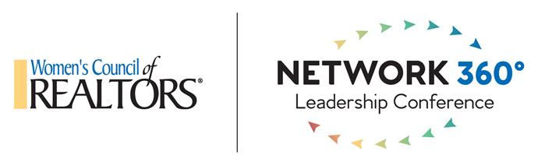

Network 360° 2023 Incoming State Network Presidents
Prior to arriving at Network 360, it is important that you have reviewed the following documents which can be found on wcr.org under in the Network Glossary:
State Operating Model
Local Operating Model
Certification Program
Insurance
LID/Leadership Pathways
Legal
Officer Reporting
Roadmap
Taxes
ByLaws
Election Procedures
Liaison/State and National Fact Sheet
Officer Job Descriptions
New Member Onboarding

