East Central Network | July 6, 2022 • 1st VP Report
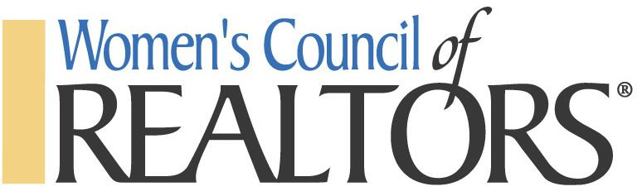

Board of Directors Meeting 07/06/22

Meeting called to order at 9:09am
Present: Steven Melchor, Rebecca Tinnin, Michele Papatheodore, Trudy Tabor, Kristine McCarty, and Christina Moon. Not Present: Gail Freeman, Matthew Bully, Chris BB, Steve Cross

Agenda Approved

President Report:
Orlando National Conference Registration: Nov 9-13 Orlando Hilton
Michele and Christina to confirm if she will be attending WCR in addition to NAR.
State Meeting will be September 20th at Amway in GR. Details to follow.
Send expenses in for Spring Meeting this week.
Welcome New Members: Kristine and Trudy in attendance.
Elections will be in November

President Elect Report: Working on New Members in a Box. Will reach out to Laurie Koelling from other network for more information.

Membership Director Report: Currently at 46 Members

Looking at Member Bags like the ones at the Golf Outing that Mason Burgess had.

Program Director: Next Event: Membership Appreciation Event at Redwood Steakhouse on July 20th
Proposed event dates for 2023 have been established.

Sales Fest 2023. Discussed deposit for Speaker, Anton Dupont. Total cost is $5,000 for 4 hours. No breaks. Date to be February 15th. Need to see if he can be approved for Con Ed credit. We need to pick a topic as well.

Golf Outing was a success. Net profit of $4,319.49 after expenses. Will having the event at Atlas next year. 2 outstanding invoices remain and in the process of being collected. One team and one hole sponsor.

Treasurer: Review of report.

1st Vice President: No report.

Old/New Business: N/A

Next Mtg Date: August 3rd, 9am at ECAR.

Adjournment: 9:56 am

