Women’s Council of REALTORS® - Idaho
July 14, 2022 at 3:00 PM
Executive Board Meeting Agenda

Approval of May meeting minutes- attached

Treasurer’s Report –

Chris Lee fundraiser $1950.00 - $650 sponsorship = $1300 with a goal of $2500.
If we have funds ready now, she is happy to accept. Are we done with the fundraiser?
Need to send to Debbie Coda with the sponsorship form

Bill Highway: Cash balance for the dues through 04/30 in Bill Highway is $4161.04

Updated Bylaw Templates: They need to be downloaded, add in our current name and dues info, and uploaded to the microsite so we have the correct ones there for our network certification. I have not been able to log in to get these documents to edit.

Upcoming Events –
06/01 – State Liaison Antigone Twidt
06/01- Application date for Leadership Institute begins
- Tom Turner and Nicole LaRossi from North Idaho has put in her application
LID Committee- has turned in recommendations
07/27-07/29- Networking 360 (PE/State Liaison head to Chicago for President Training)
08/01- Application for Network Certification begins (due 10/01)
08/11 Governing Board Meeting 3PM MST

State Elections 08/11/2022
Mary Smith First Vice President, Dianna Haug Treasurer, Tom Turner President Elect

ID State Meeting/State Training 10/05-10/09- From Amanda Pannell apannell@idahorealtors.com:
The meeting is on Friday, October 7th from 1:30pm-4:30pm. I am working on rooms and will get that info to you soon. Yes, the joint reception is on Wednesday, October 5th from 6:30pm-8:30pm in Casco/Kidd/Cape. I am still confirming events, but should have the agenda available in the next week or so.

10/05- Joint Convention- Marta still has no idea. We need to get our heads together asap.

Other: Past Presidents Scholarship- need to start a campaign for that.

Network Reports
-Boise Metro-
Please see Boise Metro Network update below:
Recent Fundraisers:
Bunco Night: April 8th, Net Profit: $750.00
Hubble Homes Happy Hour Spring Parade: May 18th, Net Profit: $1500.00
Denim & Diamonds: June 24th, Net Profit: $8500.00

Upcoming Events:
July 13th, Breakfast Meeting, Who "R" We Panel
August 10th, Jimmy Farris "Be A Pro"
August 17th: Membership Appreciation BBQ (collaboration with Canyon County)
September 14th, Breakfast Meeting, Broker Panel Mastermind
October 12th, Breakfast Meeting, Ria Allen Pepper Shock Media
November (TBD): Wine Down Officer Installation Party
December (TBD): Annual Christmas Party

Membership:
Realtor Members: 71
National Affiliates: 9
Strategic Partners: 42

Overall the Network is doing well. Our books are pristine and balanced. We had anticipated a larger attendance at our Denim & Diamonds Annual Fundraising event, but still made a nice profit.

-Canyon County- This month is our community involvement event. July 20th, 4 board members will be participating at Pink on the Dirt with set up.
Our June Paint & Sip Fundraiser was not as successful as we had hoped
Income: 1732.60
Food/Drink: $430.78
Paint: $615
Square Fees: $47.24
Eventbrite Fees: $108
Total Profit: $531.58
Kelsie is out on leave from the board. She did not say how long she would be out on leave. August we are suppose to have a Collaboration with Boise Metro, Fried is working on this and has stepped up to help cover Kelsie's board duties. I'll check in with her for an update. Frieda will also be putting together an email regarding upcoming elections and board positions available, which are
Treasurer
Program Director
Membership Director
Frieda will remain in the First Vice President position
Kelsie last stated she would like to be in the President Elect Position. I will have to confirm with her if she plans to move forward with this. I did sent a message asking all board members who planned to continue on the board and she never responded.
This was last years (2021) fundraiser
Last Years:
Income: $926.21
Food/Drink: $403.20
Paint: $575
Decor: $10.59
Square Fees: $14.90
Eventbrite Fees: $171.50
Total Profit: -$248.98
Mina Piña, Realtor®️
-SE Idaho-

-North Idaho-
These are the events for the rest of the year. The boat cruise was a success. Our next fundraiser is WCR gives back we are adopting a couple of kindergarten and or first grade classes and doing a drive for school supplies. The group is doing fine they should and out the year well. We are getting a bit better on communication so that is good.
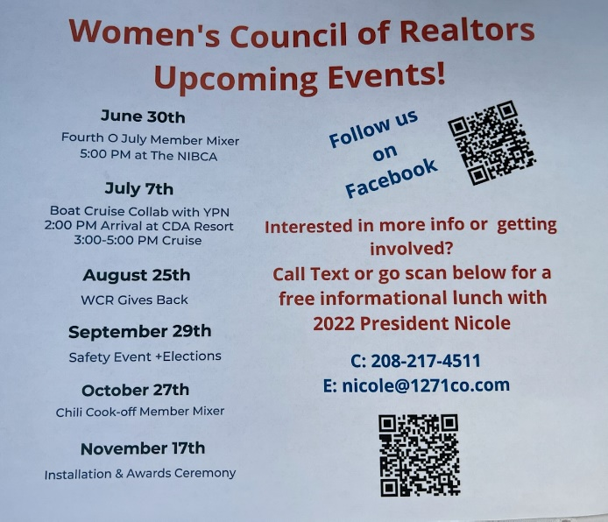

Other Business
-

