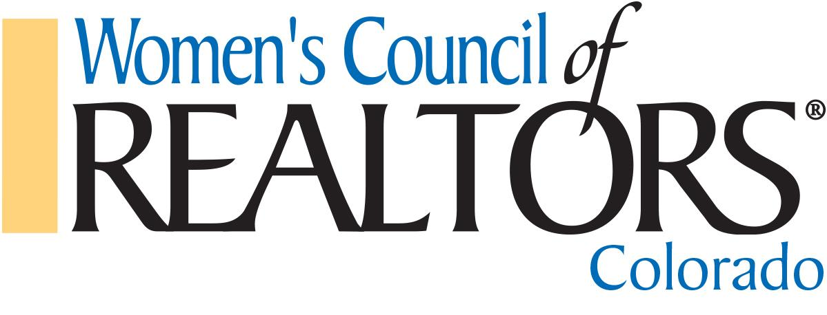
Consent to Serve
Colorado State Officers - 2024 Term of Office
I agree to serve as: PRESIDENT ELECT - FIRST VICE PRESIDENT – TREASURER – STATE LIAISON (circle one) of the Women’s Council of REALTORS® Colorado for the year 2024. I acknowledge and accept my fiduciary obligation to act in the best interests of the State organization as follows:
1. Duty of Care: I will use the care that a reasonably prudent person would exercise in a like position and under similar circumstances. This means that I agree to attend meetings, ask questions to gain the information I reasonably need to make a decision and exercise independent judgment.
2. Duty of Loyalty: I will advance the best interests and well-being of the Women’s Council, Colorado over any individual or local Network interests, and I will refrain from using my position of trust to further my own interests in a way that conflicts with the interests of the Women's Council.
3. Duty of Obedience: I will accept, support and implement Governing Board decisions, even if I voted against them, I will follow the Bylaws of Women’s Council and Standing Rules and comply with all state and federal laws relating to Women's Council activities.
4. Duty of Confidentiality: I will not discuss matters deemed confidential by the Governing Board outside of board meetings without the express advance permission of the Women’s Council Governing Board.
5. Travel & Time: I understand the time and travel requirements for the position that I have been elected to serve. I will make every effort to give of my time to meet the requirements of this position. I accept my position with the understanding I may not be funded for all or any of my expenses while performing my volunteer duties.
6. I agree to attend any mandatory State Leadership Planning Retreat, when scheduled, with the State Leadership Team and other invited guests.
Additionally, I will not speak or act for the Women's Council of REALTORS® Colorado or the Governing Board unless specifically authorized to do so. I will not present opinions about Women’s Council business unless those opinions are clearly expressed as personal opinions not necessarily the views of the Council.
My signature below acknowledges that I agree to be bound by the terms of consent above.

Signature:

Printed Name:_______________________ Date:______________________________

1 | P a g e
Candidate Application

Name: ___________________________________ Local Network Name:_________________________________________
Company Name:___________________________________________________________________________________
Street Address: _____________________________________City: ________________State: _____Zip: ____________
Primary #: ___________________________________ Cell/Text:____________________________________________
E-Mail: (mandatory)_________________________________ Website:_______________________________________
Name of your Local REALTOR® Board/Association(s)___________________________________________________
Number of years a Licensee:____________ Number of years as a Women’s Council Member: __________________
Is real estate your full-time occupation? (Circle One): Yes No (if no, please explain) ______________________________________________________________________________________________________________
______________________________________________________________________________________________________________
______________________________________________________________________________________________________________
Do you have any known health, financial or other circumstances that could limit your ability to serve? Circle One: No Yes (If yes, please, describe)
______________________________________________________________________________________________________________
______________________________________________________________________________________________________________
______________________________________________________________________________________________________________
REALTOR® Designations Earned and Currently Maintained: (Circle all that apply)
PMN ABR ABRM ARM CCIM CIPS CPM CRE CRB CRS GREEN GRI SRES SIOR E-PRO
Other REALTOR® Certifications Earned and Currently Maintained:
______________________________________________________________________________________________________________
______________________________________________________________________________________________________________
______________________________________________________________________________________________________________

2 | P a g e
Women’s Council of REALTORS® Experience
Fill out all that apply. Please indicate the year of your term (e.g. 2015 ~ 2022)
Describe significant accomplishments/contributions; use an extra sheet of paper if necessary.
Women’s Council of REALTORS® State Officer:
Governor Year(s) Served _____________________________________________________________
State Liaison Year(s) Served _____________________________________________________________
Treasurer Year(s) Served _____________________________________________________________
Secretary Year(s) Served _____________________________________________________________
President-Elect Year(s) Served _____________________________________________________________
President Year(s) Served _____________________________________________________________
State Committee/Project Team Chair/Vice-Chair:
Committee Name/s Year(s) Served _____________________________________________________________
Committee Name/s Year(s) Served _____________________________________________________________
Committee Name/s Year(s) Served _____________________________________________________________
Committee Name/s Year(s) Served _____________________________________________________________
Committee Name/s Year(s) Served _____________________________________________________________

State Committee/Project Team Member:
Committee Name/s Year(s) Served _____________________________________________________________
Committee Name/s Year(s) Served _____________________________________________________________
Committee Name/s Year(s) Served _____________________________________________________________
Women’s Council Local Network:
Membership Dir. Year(s) Served _____________________________________________________________
Event Director Year(s) Served _____________________________________________________________
Secretary Year(s) Served _____________________________________________________________
Treasurer Year(s) Served _____________________________________________________________
President-Elect Year(s) Served _____________________________________________________________
President Year(s) Served _____________________________________________________________
Local Network Committee/Project Team:
Committee Name/s Year(s) Served _____________________________________________________________
Committee Name/s Year(s) Served _____________________________________________________________
Committee Name/s Year(s) Served _____________________________________________________________
Committee Name/s Year(s) Served _____________________________________________________________

3 | P a g e
Women’s Council of REALTORS® National Leadership
National Liaison Year(s) Served ________ Executive Committee Year(s) Served ________
Regional Vice President Year(s) Served ________
Chair/Vice Chair or member of a National Committee (List the most current):
Committee Name/s Year(s) Served _____________________________________________________________
Committee Name/s Year(s) Served _____________________________________________________________
Member Strategic Committee or Project Team (List the most current)
Committee Name/s Year(s) Served _____________________________________________________________
Committee Name/s Year(s) Served _____________________________________________________________

Women’s Council of REALTORS® Leadership Institute Graduate (circle one) Yes No Year: ________
National Association of REALTORS® Association Leadership Experience
National Director: Year(s) Served _____________________________________________________________
National Association of REALTORS®/Committee Chair/Vice-Chair/Appointed Member
Committee Name/s Year(s) Served _____________________________________________________________
Committee Name/s Year(s) Served _____________________________________________________________
Committee Name/s Year(s) Served _____________________________________________________________
National Association of REALTORS® Leadership Academy Graduate (circle one) Yes No Year:_______
Colorado Association of REALTORS®
State Director: Year(s) Served _____________________________________________________________
Colorado Association of REALTORS® - Committee Chair/Vice-Chair
Committee Name/s Year(s) Served_____________________________________________________________
Committee Name/s Year(s) Served_____________________________________________________________
Colorado Association of REALTORS® - Committee Appointed/Volunteer Member:
Committee Name/s Year(s) Served _____________________________________________________________
Committee Name/s Year(s) Served _____________________________________________________________
Committee Name/s Year(s) Served _____________________________________________________________

4 | P a g e
Local Association of REALTORS®: (Circle all that apply):
President Year(s) Served _____________________________________________________________
President-Elect Year(s) Served _____________________________________________________________
Secretary Year(s) Served _____________________________________________________________
Treasurer Year(s) Served _____________________________________________________________
Director: Year(s) Served _____________________________________________________________
Committee Chair/Vice-Chair
Committee Name/s Year(s) Served _____________________________________________________________
Committee Name/s Year(s) Served _____________________________________________________________
Do you have any other major accomplishments that have not yet been included in the application? (use extra sheet of paper if necessary)
_____________________________________________________________________________________________________________
_____________________________________________________________________________________________________________
_____________________________________________________________________________________________________________

_____________________________________________________________________________________________________________
_____________________________________________________________________________________________________________
_____________________________________________________________________________________________________________
_____________________________________________________________________________________________________________
_____________________________________________________________________________________________________________
_____________________________________________________________________________________________________________
_____________________________________________________________________________________________________________
_____________________________________________________________________________________________________________
_____________________________________________________________________________________________________________
_____________________________________________________________________________________________________________
_____________________________________________________________________________________________________________
_____________________________________________________________________________________________________________

5 | P a g e
Statement of Purpose
Please submit a brief paragraph on each of the following: (use extra sheet of paper if necessary)
1. What motivates you to serve in the office for which you are seeking?
2. How have you made a difference in Women’s Council and what have you contributed?
3. What skills and qualifications do you have that will benefit the office you are seeking?
4. Describe yourself in 100 words or less:
Signature _________________________________________ Date ________
Please return the COMPLETE Application to:
WomensCouncilOfRealtorsCO@gmail.com with the subject line: “2024 Candidate Application”
**MUST include a Letter of Good Standing from your local association**

Deadline to submit application: April 24, 2023 11:59 PM “NO EXCEPTIONS”
You will be contacted by a member of the Nominating Committee if there are any questions regarding your application.

