2024 STRATEGIC PARTNERSHIP LEVELS  WOMEN’S COUNCIL OF REALTORS® ARIZONA | Platinum  $1750 | Gold  $1200 | Silver  $500 | Bronze  $350
Social media posts on the Women’s Council of REALTORS® Arizona Facebook Site | 12 | 6 | 3 | 2
Display company materials on vendor marketing table at Women’s Council of REALTORS® Arizona Events | ALL | ALL | 1 | 1
Speaking opportunity at the Women’s Council of REALTORS® Arizona Events | ALL | 2 | 1
Email advertisements to the members of all Women’s Council of REALTORS® Arizona Networks | 4 | 2 | 1
Complimentary registration at the Women’s Council of REALTORS® Arizona Events | 2/events | 1/event | 1/event
30 second video advertisement to post on the Women’s Council of REALTORS® Facebook Site | 4 | 2
Your company logo on all Women’s Council of REALTORS® Arizona Conference agendas and event fliers
Recognition certificate at Women’s Council of REALTORS® Winter Conference
Logo on Women’s Council of REALTORS® Arizona Website with hyperlink to your company website. https://www.wcr.org/network-sites/arizona/
Recognition at all Women’s Council of REALTORS® Arizona Conferences
Women’s Council of REALTORS® Strategic Partner Pin
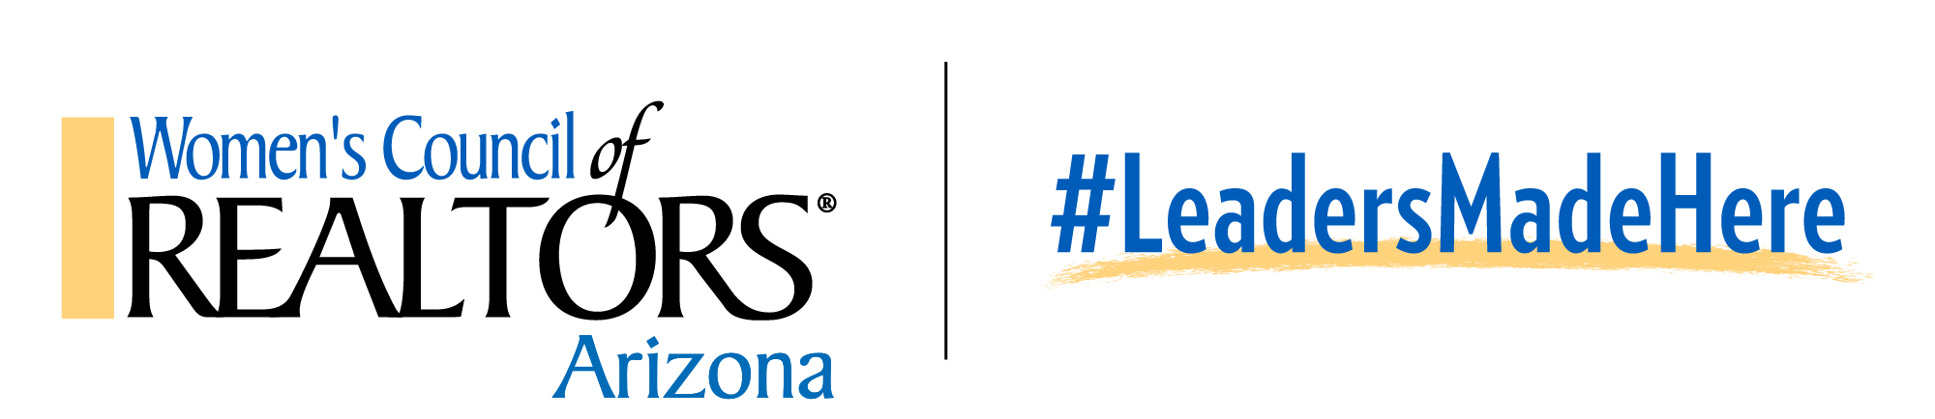
A Women’s Council of REALTORS® Arizona Strategic Partnership affords you the opportunity to network with our leaders throughout the year and reach our 400+ members via our events, website, emails and Facebook site. Our Strategic Partners enjoy years of success through their partnership with Women’s Council.

Women’s Council of REALTORS® Arizona 2024 State Events

Spring Conference - March 25-26, 2024, Gila River Resorts & Casinos, Wild Horse Pass, Chandler, Arizona

Leadership Orientation - September 18-19, 2024, Chandler, Arizona

Winter Conference & 2025 Board Installation – November 20-21, 2024, Lake Havasu City, Arizona

2024 Women’s Council of REALTORS® Arizona
Strategic Partnership Application
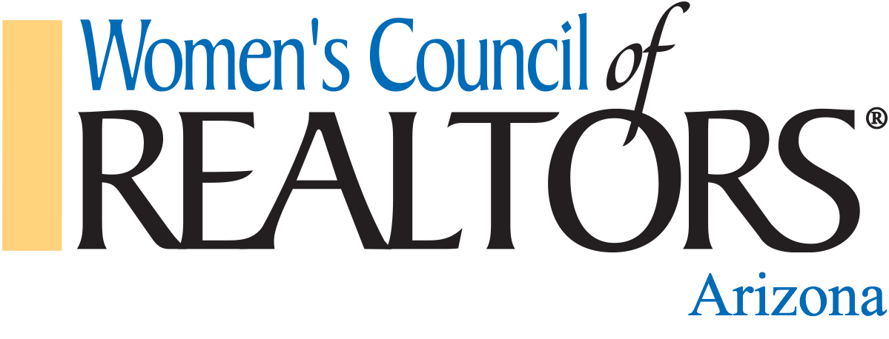

PLEASE LIST YOUR INFORMATION AS YOU WOULD LIKE IT REPRESENTED IN OUR DIRECTORY

COMPANY NAME:____________________________________WOMEN’S COUNCIL MEMBER NAME:________________________________

CELL:__________________________________ OFFICE:__________________________________ EMAIL: __________________________________

BUSINESS ADDRESS:_______________________________________________ CITY:__________________________ ST:_______ ZIP:___________

CHECK LEVEL OF STRATEGIC PARTNERSHIP:

PLATINUM - $1750 GOLD - $1200 SILVER - $500 BRONZE - $350

Please make all checks payable to Women’s Council of REALTORS® Arizona and mail your check and form to:
Susan Struse, 6659 S. Calle De La Mango, Hereford, AZ 85615

By signing below, both parties agree to Women’s Council of REALTORS® Arizona stated benefits based on the level of Strategic Partnership selected.

SIGNATURE:_________________________________________________________________ DATE:_______________________________________

To maintain a productive REALTORS®/Affiliate ratio, all Strategic Partnership Applications will be reviewed by the Board for eligibility. In 2024, the Platinum Level will be limited to ONE partnership per business type. All applications submitted will be contacted with the Board’s determination within 2 weeks of your application. The 2024 State Treasurer and 2024 Strategic Partner Chair will be your liaisons. Women’s Council Arizona reserves the right to solicit additional sponsorships for select special events outside of the events listed above, for example but not limited to evening events, fundraising events, the annual Installation event and others. Strategic Partners will be given first right of refusal on these opportunities.

ARTWORK REQUIREMENTS:
Color Logo In .PNG or .JPEG format of 300 dpi or higher

FOR QUESTIONS:
Cherie Stall, 2024 District Vice President
2024 Strategic Partner Chair hello@cheriestall.com 602-796-0744
Stephanie Grande, 2024 President Stephaniegrande@tierraantigua.com 520-488-1526
Susan Struse, 2024 Treasurer Susanstruse@longrealty.com 520-508-8911

Become a Strategic Partner Today
Build relationships and network with the most professional and successful real estate professionals in Arizona.

