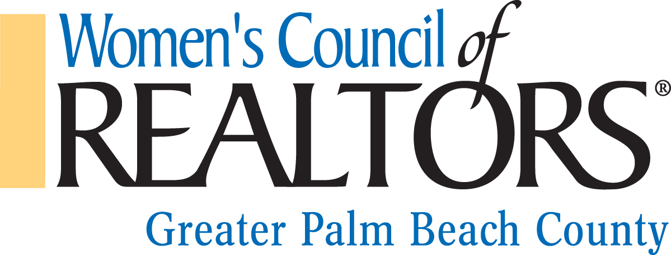

LOCAL STRATEGIC PARTNER APPLICATION 2016
Promote your Business & Partner with WCR Greater Palm Beach

Date: _________________________
INFORMATION ABOUT YOU

Name: _______________________________________________________________________

Company Name: ________________________________________________________________

Company Address: ______________________________________________________________

City/State/Zip: _________________________________________________________________

Home Address: ________________________________________________________________

City/State/Zip: _________________________________________________________________

Mobile Phone: _________________________________________________________________

Office Phone: __________________________________________________________________

Email: ________________________________________________________________________

Fax: _________________________________________________________________________

Website Address: ______________________________________________________________

Birthday Month/Day: ___________________________________________________________

-Please pay online or make a $200 check payable to: WCR Greater Palm Beach County Chapter

-And return your application with check to:

Greater Palm Beach County WCR Chapter
Attn.: Jessica Rosato
900 East Atlantic Avenue Suite 18
Delray Beach, FL 33483

“Affiliate of the Month” is also available for $250. Including only the month you are sponsoring, you would receive a 5-minute speaking opportunity at one of our business resource meetings, distribution of marketing materials at each seat at the meeting and at the partner table, and company logo on agenda, evaluation, meeting flyer and on all social media and WCR Facebook page.

