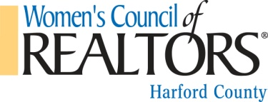
Women’s Council of REALTORS® Harford County Network
LOCAL STRATEGIC PARTNER APPLICATION:

Name:_______________________________________________________________________________

Company Name:_______________________________________________________________________

Company Address:__________________________________City/State/Zip:_______________________

Phone Number:____________________________________ Fax:________________________________

Website: _________________________________________Email: ______________________________

Residence Address:_________________________________ City/State/Zip:_______ _______________

Please send mail to: _____ HOME ______BUSINESS

Recommending Member Signature: _______________________________________________________

Description of your Business: _____________________________________________________________________________________
_____________________________________________________________________________________
_____________________________________________________________________________________

Local Network you are joining: HARFORD COUNTY
_{Local Dues:} $150.00 per year, period beginning _________________________________________

Definition of a Local Strategic Partner: Local strategic partners include individuals engaged in but not limited to a specialty of the real estate business and who are not associated with a firm engaged in the sale, rental management, appraisal of real property or real estate counseling and who shall not be required to hold membership in the Local Board. Local Strategic Partners shall pay only local dues and may attend local meetings, be a member of a committee, and chair a special committee or task force. They may not vote, hold office, use WCR logos or symbols or avail themselves of National WCR services.

By signing you are committing to become a local strategic partner of the Women’s Council of REALTORS® Harford County Network and entering into a partnership with our realtor membership in which we will strive to support common goals & endeavor to provide ongoing resources to each other.

Local Affiliate Signature:_____________________________________ Date:_______________________

Please send application with check made payable to:
WCR – Harford County Chapter
PO Box 295
Bel Air MD 21014
Attn: Julie King – President Elect

