2017
Strategic Partner Member of the Year
Karen Brown
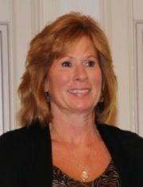

Karen Brown has been involved with Women’s Networking Group since 2004. She served as the Secretary in 2011 and 2012.
Karen has been a Fashion Show committee member from 2005-2017.
She has been active in the Dayton Area Board of Realtors and the Dayton Humane Society as well as various community and civic organizations.
Karen is the Chief Operating Officer of Landmark Title Agency, South!

Landmark Title Agency South
The Renaissance Building
280 Regency Ridge Suite 1500
Dayton, Ohio 45459
(937) 432-6300
(800) 660-5284
Fax (937) 432-6075

